JANUARY, 2008 No. 19
SHÚSHIN KAI GOJU RYU KARATE


kiai !!!!

2007 BREAKUP & GRADING RESULTS
A really successful Breakup night was held at the Hillside dojo on 18th December. A good class was in attendance for a tough workout on basics, bunkai, sparring and kata for the grading. Many thanks to the black belts who assisted with the grading!
Also many thanks to Bill who video’d the evening for us. Also re the raffle...many thanks to Mick who again led the raffle. And to Ling who assisted.
Many, many thanks to those who supported the raffle by donating money and prizes.
And to all members who assisted the club by selling raffle tickets. Thank you all.
Marc Del Cimutto from Tullamarine won this year's Junior Student of the Year Award, and received a certificate and club shirt. Well done Marc!!
Grading results, in no particular order ...Promoted to....
9th Kyu
Amie Kelly
5th Kyu
Trevor Honan
4th Kyu
Paige McDowell
Gregory Georgiadis
Nicole Georgiadis
2nd Kyu
Fabian Ulpiano
Marc Del Cimmuto
1st Kyu
Andrew Noble

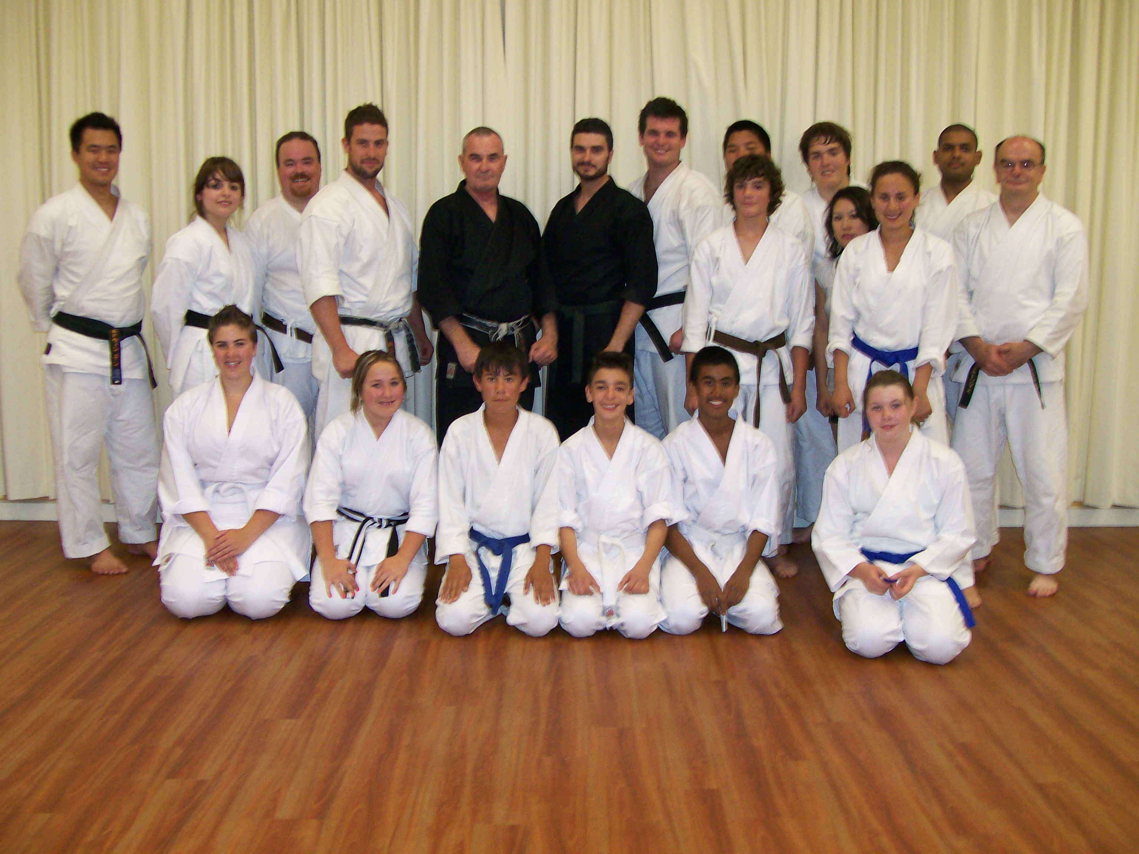

The class at the last night of training at Hillside, 2007.

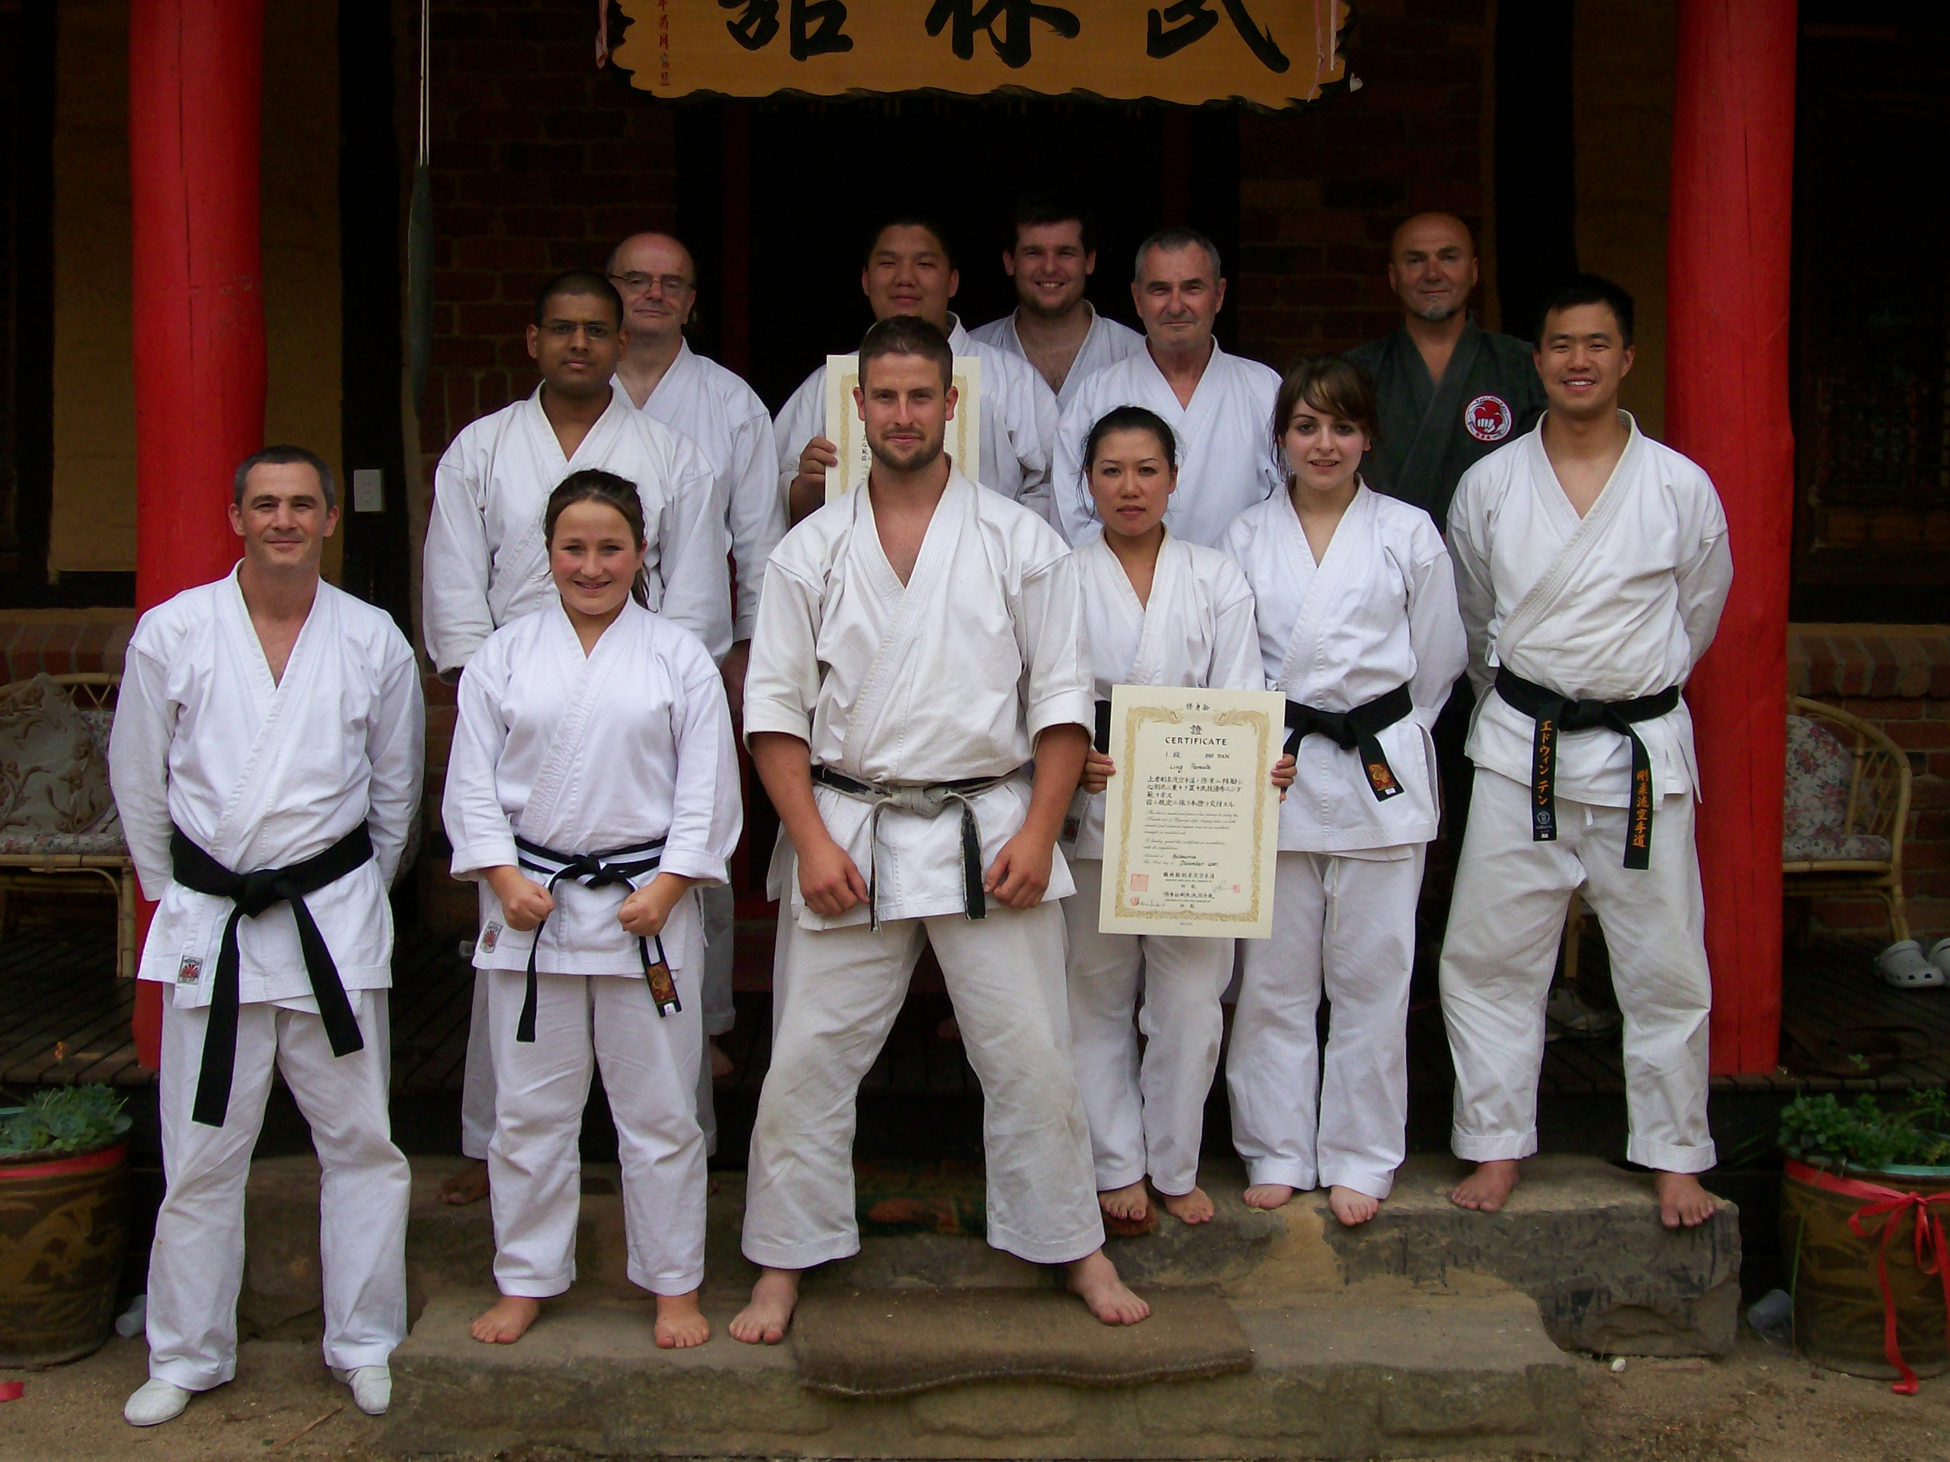

Black Belts and Kyoshi after the camp (Photo taken by Sensei Lincoln)

CAMPS & GRADINGS AT WU LIN
On Sunday, 15th April our senior group travelled to Wu Lin for a special training session with Kyoshi James Sumarac.
On the weekend of 26/27 May a Kyu Grade Camp was held at Wu Lin for Kyu grades and a number of our members attended and all had a great time. Ling, Tegan, Fabian, Vanessa, Nicole, Meagan, Frank and Trevor attended along with Sensei Graeme and Sempai Bill. Sempai’s Edwin and Michael joined the group on Sunday also.
On the weekend of 21/22/23 September, Sensei Graeme and Sempai Bill attended a Tai Chi workshop at Wu Lin, conducted by Master Chen Yun Ching, the son of legendary Tai Chi Master Chen Pan Ling. This was the fourth Tai Chi/Kung Fu seminar conducted by Sifi Chen attended by Sensei Graeme. On this occasion the main items of study were the “Form of China” Tai Chi form, Peng Chuan (Mountain Top Boxing) and Bagua.
The big event for us at Wu Lin in 2007 was the Black Belt Training Camp and Grading conducted by Kyoshi Sumarac on the weekend of 1st and 2nd December. We had a really strong group in attendance, and everybody had an exhausting but happy time!! The highlight was the Grading which saw our club receive our biggest Dan Grading result ever!!!
Promoted to Junior Shodan (1st Dan)
Tegan Berezny
Promoted to Shodan (1st Dan)
Ling Parente
Vanessa Ulpiano
Frank Dellevoet
Asanka Silva
Lucas Kong
Promoted to Sandan (3rd Dan)
Bill Demertzidis
Promoted to Godan (5th Dan)
Graeme McConnell-Brown
Congratulations to all those who progressed their martial arts into the black belt ranks!!!!!!
ANNUAL XMAS RAFFLE
1st prize went to Christy, Asanka’s fiancé. 2nd prize to Doctor Edwin Ten. 3rd prize went to a workmate of Andrew Noble, and 4th prize went to Ling Parente.
Many thanks to those who assisted the raffle by selling tickets, and a special mention to Amie, Frank, Ness and Paige for selling all their tickets.
A few members sold none (thanks for your effort) and some never returned their tickets or money raised.
XMAS DINNER
On December 20th, the club held its Annual Xmas Dinner at the Taylor’s Lakes Hotel. Some 27 people attended, and all had a great night!
21ST ANNIVERSARY
2007 was the 21st Anniversary of the club, as it was 21 years ago that Sensei Graeme and Sensei Lincoln started the club’s first dojo at Tullamarine Primary School. Hundreds of students have practiced with us since then, and the senior black belt group began training in those early days, and continue to practice. On Saturday, 19th May, the club held a celebratory Anniversary Dinner at Il Portobello Restaurant in Essendon, which was attended by almost all of our members. Kyoshi James Sumarac attended with Shou-Mei as our Guests of Honour. To celebrate the occasion, all those attending were presented with a complimentary DVD showing highlights of the club’s history. We were very fortunate that way back in the distant past, even before Tullamarine dojo opened, we had access to video equipment! A special narrated, 2 DVD set was later produced and made available to members. Many thanks to Bill who spent countless hours producing the DVD’s and to Ling who organized the dinner, and birthday cake!
KUNG FU NIGHT
On 17th November we held our Annual Kung Fu BBQ & movie night at Sensei’s dojo. This year we showed some historical videos from Bundeena training camps. plus video of Sensei Lincoln’s graduation.
WEBSITE
Our website www.goju.com.au is still attracting a good number of visits since it was introduced in January 1999. At this time of writing, the site is has received 40,133 visits Many thanks to Suraj and Bill who look after the technical side of the site in between working, studying and partying. This year we will add new features to the website to make it more informative for potential new members. Suraj and Andrew are currently working on this from a technical standpoint, and other members will be asked to contribute. The photo section has been recently updated, with photos from the Training Day, Black belt Camp, Xmas Dinner, and the Breakup Night at Hillside.
ASSOCIATED WEBSITES
If you are interested in finding out more about the Tai Chi, Mountain Top Boxing, Bagua and Hsing-I practiced and taught in our school, please visit www.chenpanling.com Additionally, please visit Kyoshi’s website www.jamessumarac.com which includes photos from the various camps and seminars.
STRATEGY PLANNING GROUP
In December, a group of senior members met at Sensei’s house to discuss strategies and plans for guiding the club into the years ahead, to help attract new members, and how to retain members. A number of initiatives were discussed, the main two directions being to develop the website as a marketing tool, to make it more informative and attractive to potential new members, and a new member starting package. Both initiatives will be introduced during the year, our target date being the end of June at the latest. Those taking responsibility for various activities will be talking to members and asking for support and help. Would everybody please cooperate as much as you can if asked!
ANNUAL TRAINING DAY
On Saturday, 6th October we held our third Annual Training Day and Competition at Ginifer dojo. Some 25 members came along and supported the day, which was designed and conducted by Sensei Lincoln. During the day members were taught kata Happoren by the 1st Kyu’s as part of their Black Belt grading, learned the first several movements from Bagua, did heaps of partner drills, and competed in our second in-house tournament. The tournament was designed by Sensei Lincoln to incorporate a “grading” or “handicap” system so lower grades and females received higher scores for fighting higher grades, thus giving everybody a fair chance of winning. Also, the sparring was not along competition lines as experienced at AKF events, but was based on close quarter sparring of 30 seconds duration. The ultimate winner and Champion for the third time was Edwin Ten who received a trophy for his victory.
Additionally, with a Black Belt grading coming up at Wu Lin all 1st Kyu’s underwent a dojo level grading at which all were successful. Their grades were confirmed at the Black Belt camp. At the Training Day, Sempai Suraj Fernando also underwent an exhausting test for Nidan (2nd Dan), at which he was successful. Well done to Suraj!!!
TRAINING WITH KYOSHI
During the year a number of training sessions other than the formal camps were attended with Kyoshi Sumarac. As mentioned earlier, On Sunday 15th April all Black Belts and 1st Kyu’s attended an afternoon workshop at Wu-Lin. During the year, Sensei Graeme has attended Wu-Lin every Thursday for a Tai chi class and karate class with Kyoshi. Sempai Bill has attended several of these sessions. Additionally, Sensei Graeme and Sensei Lincoln attend Black Belt training with Kyoshi at LaTrobe University on the first Tuesday night of each month. Sempai’s Bill, Suraj and Edwin have also attended these sessions.

PROGRESS IN 2007
During 2007 we consolidated our journey into the syllabus of Gojukensha under the guidance of Kyoshi James Sumarac (7th Dan), Chief Instructor of Kakurinkan Goju Ryu Karate, with which we are affiliated.
During the year we also saw the usual comings and goings with some people trying karate for a short time before disappearing, and we also had some rejoin who had discontinued their martial arts journey.
We wish to thank our new members for choosing our club, and hope that you enjoy your karate journey.
We had some major events during the year…..the club’s 21st Birthday dinner, a very successful Annual Training Day, a Kyu Grade camp, and a Black Belt camp. We had Tai Chi seminars as well as three successful Kyu gradings.
The most important event of all was the Black belt camp during which a grading was held, and we gained a 5th Dan, a 3rd Dan and 6 new Shodans.
SURAJ FERNANDO
Suraj, who has been a student of ours for many years gained his 2nd Dan this year and promptly took off for 2 years working in England. We all realize that he had to leave Australia to let things cool off, and that they don’t know him over there yet, so he’s safe for a while. Suraj keeps in touch with us all by email, and sending us pictures of his travels, most of which is made up, and didn’t actually happen. If Suraj gets deported, he’ll be home sooner than he planned. In the meantime, we all wish Suraj all the best in his adventures.
NEW HILLSIDE DOJO
This year we opened our new Hillside dojo after some 6 or 7 years at the Hillside Community Centre. The new dojo at the Banchory Community Centre, Banchory Ave, Hillside, is a brand new facility with a purpose built martial arts room equipped with mirrors and a clean floor. Unfortunately we can’t get access until the exact time of 7.00pm on Tuesdays, which makes starting class on time a problem, and the Scouts who also use the centre seem to think that they own it by making as much noise as possible, without any consideration for other users. Makes meditation and quiet work quite impossible. At least the place is ours alone on Thursdays.
IMPORTANT NEWS : FEE INCREASE
After much deliberation the Management Committee of the club (2nd Dans and higher, and the JKA President) have decided on a fee increase for this year. The last fee increase was early 2006. That was the first increase for 5 years. Our new fees which our research tells us are still lower than fees charged by other clubs, are:
Annual Membership Fee $75 (unchanged)
Monthly Training Fees
Senior (12 yrs & over & Juniors 2 hrs per night) $65
Casual fee for this group $15 per session
Juniors (11 yrs & under, 1 hr per night) $50
Casual fees for this group $10 per session.
Special discounts
If members pay fees 3 or more months in advance we will apply a 10% Discount. This will mean the senior fee becomes $175.50, for 3 months, which is $4.50 cheaper than the current rate. The Junior rate will become $135 which is the same as the current rate. In other words, if members pay fees 3 months or more in advance, then for Seniors, you will get a $4.50 reduction, and Juniors will have no fee increase at all.
Would all members please pay their fees promptly on the FIRST training night of each month. (Which means of course, bring your fees to the first night back in class).
POLO SHIRTS
Any club members wishing to obtain the club’s white polo shirt embroidered with the club’s name should see me to arrange obtaining one. This shirt is worn by club members when attending official club events, tournaments and so on. Price:- $35.
BLACK TRAINING TOPS
Embroidered with the Shúshin Kai name front and back, made from non-pilling polar fleece. Please see me to arrange your top if you would like one. Price is $55, adult sizes only. These tops are designed to be worn over your uniform and are great for wearing on those cold nights. They are the only additional clothing permitted to be worn in class. This is the famous black training top made famous by Asanka………..
THE SHÚSHIN KAI NAME
For the information of members, SHÚSHIN is pronounced as a long “u” sound, and could be spelled SHU-USHIN”.
SHÚSHIN means “to improve one’s-self through one’s own efforts”, which is a very important concept in martial arts. It means that to grow and advance in anything, we must all put in our own concentrated, best effort. Nobody else can do it for us. We have to do it on our own. People will teach you, help you, support you and so on, but at the end of the day, it’s UP TO YOU. This is a very important concept, especially for our younger members. So, if you want to progress, to get faster, fitter, more flexible, improve some aspect of your karate (or your life), want to lose weight, and so on, it’s UP TO YOU!!! As a human being, you can take action!!! You’re not a tree!!!
A very important saying I learned a long time ago which may help you is… IF IT’S TO BE, IT’S UP TO ME.
“KAI” means “club”. The official club logo and name is always shown in a script called “Flat Brush”.
BETWEEN NOW & THE START OF CLASSES
I have spoken to several members since classes finished last year, and received emails from others. I am particularly pleased that these people are continuing to do some training and fitness work (such as running) over the Xmas/New Year period. There is no doubt this is a dangerous time for your fitness and standard, not to mention weight gain!!
Please make sure you do some training before class comes back, so we can hit the ground running!!
WINDS OF TRADITION
Kyoshi’s textbooks “Winds of Tradition” form the basis of our Syllabus up to and including 1st Kyu. We have arranged for these books to be available to members for a special discount price. Details are attached to this newsletter.
THE YEAR AHEAD
I am looking forward with great anticipation to seeing you all when class recommences. I am sure 2008 will be exciting and productive for everybody!!! See you back in class………..
Shihan Graeme

