SHÚSHIN KAI GOJU RYU KARATE

JANUARY, 2017 No. 29

kiai !!!!

2016 BREAKUP & GRADING RESULTS
A successful Breakup night was held at the Hillside dojo on 20P^{thP} December. Grading results………

Promoted to 2nd Kyu Brown Belt
Alex Hodge (Hillside))

Promoted to 3rd kyu Kyu Brown Belt
Shane Huntington (Hillside)

Promoted to 5th Kyu Blue Belt
Kabir Chaudhry (Hillside)
Craig Smith (Hillside)
Stephen Afflitto (Westmeadows)
Nathan Daws (Westmeadows)
Darren Alejandrino (Hillside)

Promoted to 6th Kyu Orange Belt
Jake Daglis (Westmeadows)
Con Daglis (Westmeadows)
Ali Yekenkurul (Westmeadows)
Zeyn Kekenkurul Westmeadows)
Jack Daws (Westmeadows)

Promoted to 7th Kyu
Nicolas Ioannou (Hillside)

Promoted to 8th Kyu
Javeria Naved (Hillside)
Daniella Smith (Hillside)

New belts and Certificates will be awarded on the first night back in class.

XMAS BBQ
On 11th December the club held its Annual Xmas function on the banks of the Maribynong River at Maribynong. This was the second time we had our Xmas breakup function as a family day out. The afternoon took the form of a family BBQ and then those with excess energy played a game of friendly cricket. Last year we had an all time record when around 55 people attended. This year the day was not supported so well and a lot of members decided to not support this event. I would sincerely hope that this isn’t repeated this year. We didn’t get any photos this year either so we can’t share much of interest here. Thank you to those who attended. Many thanks to Suraj who organised the event for everyone.

STUDENT OF THE YEAR
Once again we had our Student of the Year Award presented on our breakup night. This is something of a poisoned chalice, because some recent recipients have not continued their karate studies………. So this year we thought, ok, let’s try again…… We are pleased to announce this year’s winner was Jake Daglis a very talented young man from our Westmeadows dojo who along with his father Con, have attended class regularly and shown great improvement and dedication to karate studies. We are looking forward to Jake continuing his karate career well into the future and realizing his full potential. Well done Jake !!!
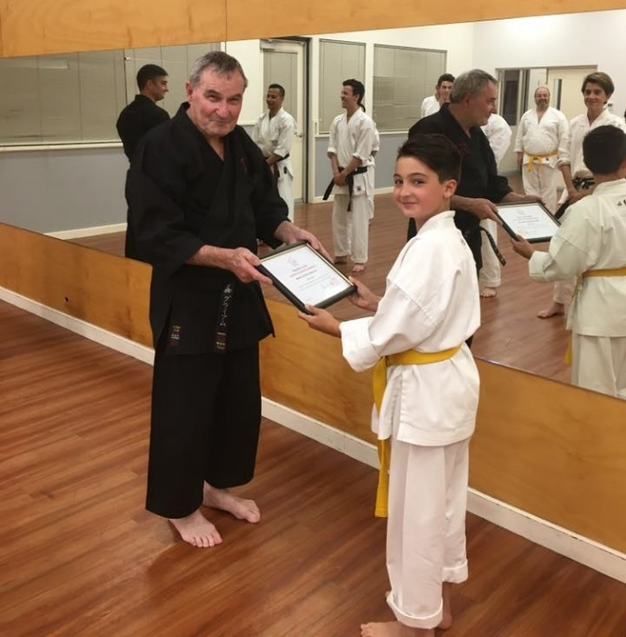

ANNUAL TRAINING DAY 2015
On Saturday, 8th October we held our 12th Annual Training Day and Competition at the Westmeadows dojo. (Bundeena seems a long time ago now !!). Thank you all for attending and helping to make the day enjoyable and productive!!
Before each session during the day Erjan and Sean took the class for warmups and stretching. This was part of their Black Belt grading assessment.
In the first two morning sessions Lincoln Sensei taught Tensho kata and applications. Tensho has undergone some substantial technical changes for us since we became a part of the Shigaku Kan dojo in Tokyo, so this was time well spent in consolidating our learnings and making sure we were all on the right path. These sessions were revisions and applications of last year’s sessions.
This was followed by the Black Belt kata grading test for Sean and Erjan.. Firstly their assignments “What karate means to me” were read out to the class. These essays were thoughtfully written and showed a great insight into the thinking of the applicants. The assignments are loaded on our website. After this, they each were called upon to demonstrate a number of katas to the whole class in a very formal environment. They all did well except Erjan needs to confirm his grading at the 2017 Training Day to show further consolidation of his knowledge.
After lunch Lincoln Sensei continued the exploration of Tensho kata by practicing bunkai, applied karate. Shihan Graeme then took the class for a session on Timing and Chance.
In the afternoon we also held our Annual in-club sparring competition for adults and juniors. There was very spirited sparring, particularly the juniors!!!. This year, the juniors and seniors again competed together with strict safety protocols in place.
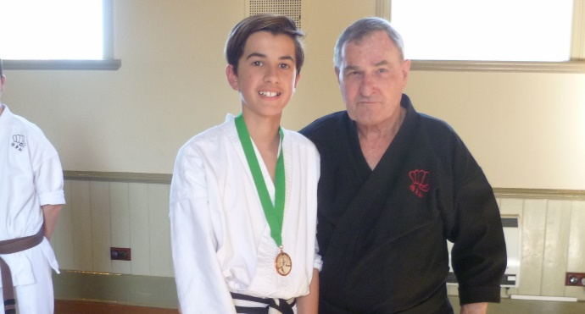
Jerome Vella won the Junior section of the Club Kumite Championship, pictured here wearing his medal with Shihan Graeme

Thank you to everybody who came along to support the event, and particularly to Suraj who organized life saving food and drinks, and Sensei Lincoln who organized the whole day plus taught and conducted and refereed the sparring competition. Thanks also to Vicki, Suraj and Sophie who officiated as timekeepers and scorers.

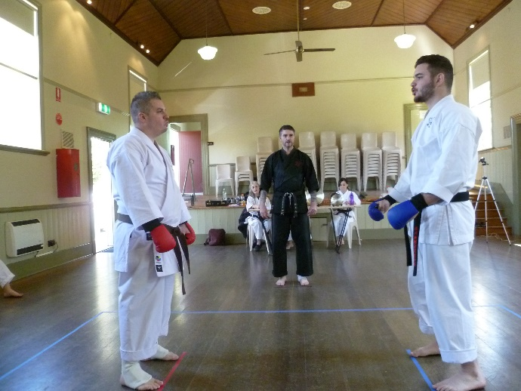
Eventual winner Sean faces challenger Marc in the club kumite competition.

NEW DAN GRADES
A major highlight of the day was the promotion of Sean and Erjan to 1st Dan Black Belt.
Their promotion was very well deserved, so congratulations to you both.
In the evening, after the Training Day, all the Black Belts met for dinner at Chiba Japanese Restaurant in Moonee Ponds..

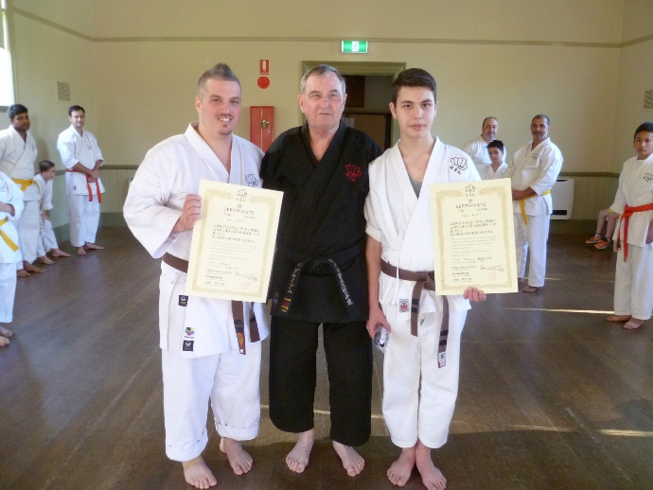
Sean and Erjan pictured here with their new certificates..

SHUSHIN KAI CLUB CHAMPION
Our Shushin Kai Kumite Championship was again conducted with great spirit and skills Sean Carville was the 2016 winner and was presented with a plate engraved with his victory. Well done Sean. The tournament incorporated a “grading” or “handicap” system. Lower grades and females received higher scores for fighting higher grades, thus giving everybody a fair chance of winning. The sparring was based on close quarter self defence sparring of 30 seconds duration. This year under strict control rules, the juniors competed for their own winner This year’s winner was Jerome Vella.

WEBSITE
Our website www.goju.com.au continues to attract visitors and provides an email facility for interested people to contact us with a view to joining. If you have not visited the website, please do so as it is full of good information!!!

FACEBOOK
Our Facebook is ShushinKaiGojuRyuKarate, or there is a live link from the bottom of the Home Page on our website www.goju.com.au
Please visit our Facebook page regularly as it carries more up to date, day to day information than the website. Please “like” us, share pages and invite your friends to visit and “like” us. Please feel free to make entries and comments.

FUNDRAISING
To meet the costs of running the club members have been busy fundraising. This year we held two chocolate drives. Thank you to everybody who supported us. We are a very small club and have some major fixed costs (particularly insurance and advertising) that we cannot cover with fees alone. A huge thanks also to Suraj who administers the choco drives.

JAPAN TRAINING
In 2016 Shihan Graeme, Marc DelCimmuto and Sophie Karavars were scheduled to visit Japan to train with our teacher, Tsubamoto Sensei, 10th Dan. However due to Shihan’s wife being hospitalized it was necessary to cancel the trip. Plans are to visit Japan in 2017.

SHIHAN’S WIFE ILL
At the end of September, My wife was admitted to hospital for a difficult operation. Unfortunately things didn’t go well and as a result she spent 4 weeks in intensive care, and finally made it home on December 9th after 10 weeks in hospital. She is now slowly recovering at home with regular rehab visits to our local hospital. I would like to thank all the senior students and black belts who supported me and Sensei Lincoln during this stressful time. We both greatly appreciate your support in keeping our dojos operating as well as your messages of support.

IMPORTANT NEWS : FEES
This year once again (7th year), there will be no increase in training fees.

Given that we are not increasing training fees would all members please pay their fees promptly on the FIRST training night of each month. (Which means of course, bring your fees to the first night back in class).

PAYING FEES
We accept cash or cheque for any fees.
You can also pay your fees via direct banking on the internet.
Ask Shihan for the banking details.

2017 CLASSES START DATES

Westmeadows Dojo (Home dojo, present members only) : Wednesday, 1st February at 7.00 pm

Westmeadows dojo, (Westmeadows Hall, Raleigh St, Westmeadows) : Monday, 6th February, at 7.00 pm

Hillside Dojo (Banchory Community Centre, Banchory Ave, Hillside): Tuesday 7th February at 7.00pm.

THE YEAR AHEAD IN SHÚSHINKAI
We are looking forward with great anticipation to seeing you all when class recommences. We are sure 2017 will be exciting and productive for everybody!!!
See you back in class………..
Shihan Graeme
Sensei Lincoln
January, 2017

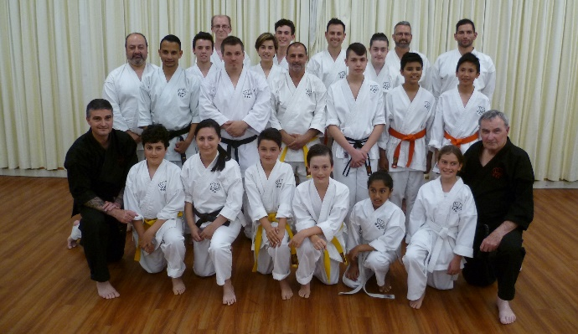

The group photograph of Shushin Kai members taken at Hillside dojo at our Breakup night, 2016.

