SHÚSHIN KAI GOJU RYU KARATE

JANUARY, 2013 No. 24

kiai !!!!

2012 BREAKUP & GRADING RESULTS
A successful Breakup night was held at the Hillside dojo on 15P^{thP} December.

Grading results, in no particular order …………………

Promoted to 5th Kyu Blue Belt
Sean Carville

Promoted to 6th Kyu Orange Belt
Mark Walshe

Promoted to 7th ^{h} Kyu Yellow Belt
Jacob Vella
Jerome Vella
Zachary Sgariglia

Promoted to 8th Kyu
Zeno Almeida

New belts and Certificates will be awarded on the first night back in class.

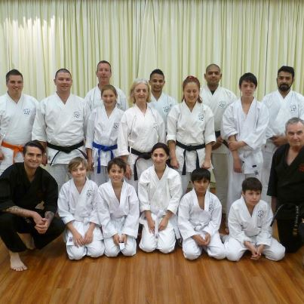
The last class for 2012 at the Hillside dojo.

XMAS DINNER
On December 19th the club held its Annual Xmas Dinner at the Legends Bistro at the Moonee Valley Racing Club. Some 24 or so people attended, and all had a great night!

STUDENT OF THE YEAR
The prestigious “Student of the Year” award for 2012 was awarded to Zachary Sgarglia from the Hillside dojo at our last night of training for 2012. In my 32 years of karate I have never before met a young person who asks as many deep, questions about the martial arts as Zachary. His intense mental approach to karate along with his motivation and love of karate led to this award. Zachary is so upfront that he is the only junior in all those years who actually gave an acceptance speech. I am looking to Zac along with our other outstanding juniors to become fine citizens of the world who will take Ichikawa karate to future generations. 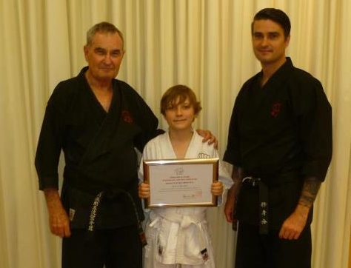
Zachary with his “Student of 2012 Award” Certificate, with Shihan Graeme and Sensei Lincoln.

WEBSITE
Our website Uwww.goju.com.au continues to present our club to the public. It has recently been updated with new photos, and club information.

FACEBOOK
We setup our Facebook page during the year. You can find us at ShushinKaiGojuRyuKarate
Or, there is a live link from the bottom of the Home Page on our website www.goju.com.au
Please visit our Facebook page regularly as it carries more up to date, day to day information than the website. Please “like” us, share pages and invite your friends to visit and “like” us. Please feel free to make entries and comments.

ANNUAL TRAINING DAY 2012
On Saturday, 6th October we held our seventh Annual Training Day and Competition at Ginifer dojo. Thank you all for attending and helping to make the day enjoyable and productive!! Sensei Lincoln taught an advanced level of Kamae Kumite. Shihan Graeme taught the kata Naihanchi Sandan which we require to know with our affiliation to Shigaku Kan in Japan.
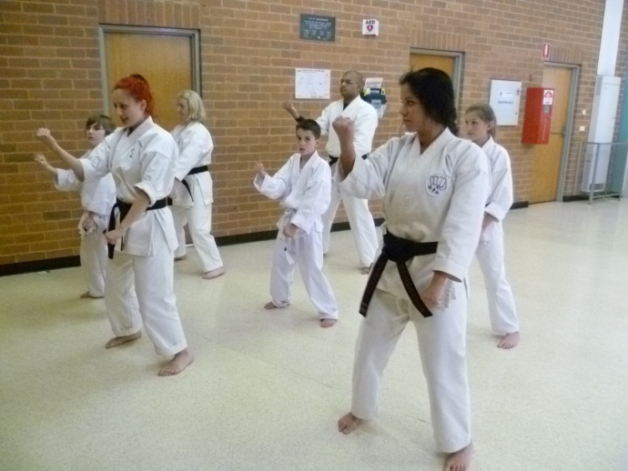
Nicole Georgiadis and Kimberley Johnson lead a group practicing Naihanchi Sandan.

In the evening, after the Training Day, all the Black Belts met for dinner at Chiba Japanese Restaurant.

Our Shushin Kai Kumite Championship was again conducted with great spirit and skills. Suraj Fernando, 2nd Dan, from The Tullamarine dojo was the 2012 winner and was presented with a plate engraved with his victory! Well done Suraj!!! The tournament was designed to incorporate a “grading” or “handicap” system so lower grades and females received higher scores for fighting higher grades, thus giving everybody a fair chance of winning. Also, the sparring was not based on AKF rules, but on close quarter sparring of 30 seconds duration.
Once again, thanks to Suraj for arranging lunch/drinks etc. Also Vicki and Edwin for doing the admin for the kumite, and Sensei Lincoln who not only refereed for 2 hours and taught several sessions, but who planned and organised the whole event. Thanks to you all!

The club now has 11 Black Belts:- Six 1st Dans, one 2nd dan, two 3rd dans, one 4th dan and one 5th dan.

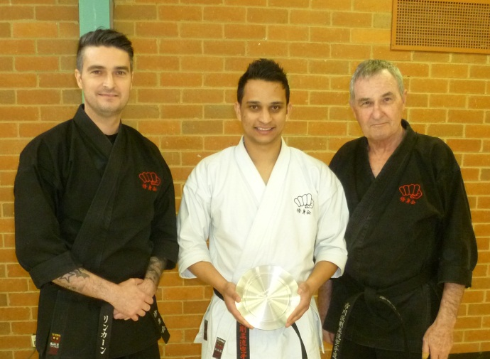
VISIT TO JAPAN BY SHIHAN GRAEME
In May, Shihan Graeme travelled to Japan to train with Tsubamoto Sensei for 2 weeks.
This, my fourth trip to japan to train with Sensei Tsubmoto was by all means the most difficult, yet most enlightening. I must be a slow learner (don’t say anything!!!) but it seemed for me that many things fell into place, and many previous lessons finally got through to me. The karate we are learning now is very difficult to understand and even harder to get right consistently, if at all.
We concentrated on preparatory exercises, and heaps and heaps of basics. For the first time we practiced semi prearranged sparring.
So this visit was a “consolidation” of previous learnings. I think we were exposed to so much over the previous 4 years that we missed many of the finer points. Sensei Tsubamoto sought my assurance that I would practice diligently what he taught me, and that I would pass it on faithfully to my students. I promised him that I would.
I would like to thank Sensei and all members of Shigakukan for their friendship and instruction.

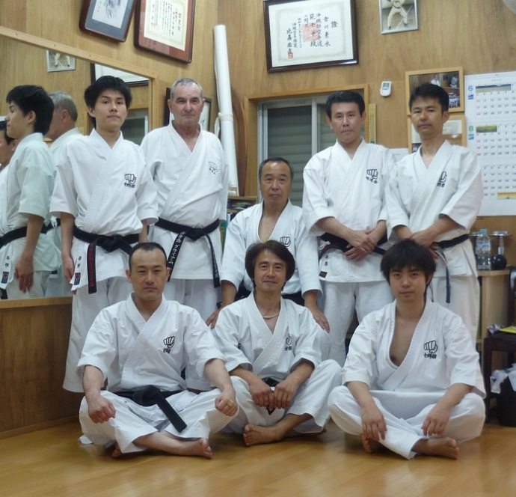
Shihan Graeme with Sensei Tsubamoto (sitting middle of back row) with some members of Shigakukan after training. Sensei Ishii is sitting front row middle.

VISIT TO JAPAN 2013
It is planned for Shihan Graeme to visit Japan again this year, taking a select group of Black Belts.. Details will be advised when plans firm up.

FUNDRAISING
To meet the costs of running the club and to support planned visits to Japan, and possible visits to Australia by Shigakukan teachers, members of our club have been busy fundraising. Our major effort was a successful chocolate drive. Thank you to everybody who supported us.
We are a very small club and have some major fixed costs (particularly insurance and advertising) that we cannot cover with fees alone.

IMPORTANT NEWS
Change to Monday night classes….. …..Westmeadows Dojo (Raleigh St, Westmeadows) closes….classes shift to Hombu Dojo.
This year we are closing the dojo at Westmeadows, in Raleigh St. Basically the numbers are not there to support the rent. If everybody who shows Westmeadows/Tullamarine as their dojo on their Membership form came at the same time we would have a class of 12 adults. However whilst that occasionally happens, we really only average 4 or 5, and on some occasions during the year we have had only 2. We have been also disappointed with the continuing bad condition of the Westmeadows Hall floor. It hasn’t been resurfaced for 2 years and basically we are training in bare feet on dirty raw boards. Not good enough considering the rent we pay. So, from Monday 5th February we are closing the Westmeadows hall dojo and instead will hold the class at the Hombu (home) dojo, which is at my home in Westmeadows. Monday night will not be available for potential new students to come along and “have a look”. To do that they will need to visit Ginifer dojo on a Wednesday. Only Members of Shushinkai will have access to the hombu dojo.
The Hombu dojo has been used for many years for Black Belt classes, plus other prearranged special training classes.
For those of you who haven’t been before, I will advise you address details privately. The dojo is operated as a Japanese dojo. No shoes are permitted in the dojo, and all personal belongings must be left outside. The floor must be cleaned after every class. There are very limited changing facilities so it is suggested you come wearing your gi. There is no room for visitors to “watch a class”.
The Hombu dojo has the best floor of all our dojos, and as Shodan Adam says, it feels and looks like a real dojo, not a school or council hall.

IMPORTANT NEWS : FEES
This year once again there will be no increase in training fees or Membership Fees.,
Given that we are not increasing fees would all members please pay their fees promptly on the FIRST training night of each month. (Which means of course, bring your fees to the first night back in class).

PAYING FEES
We accept cash or cheque for any fees.
Cheques should be made payable to “Japanese Karate Academy Inc” or just “JKA Inc.” You can also pay your fees via direct banking on the internet.
We bank with BANKMECU
BSB 803-140
Name of Account: Japanese Karate Academy Inc.
Account Number: 14069239
When making payments please add a description (i.e. Membership Fees), and send Shihan a short email (sensei@primus.com.au ) saying you have made the payment.

2013 CLASSES START DATES

Hillside Dojo (Banchory Ave, Hillside): Tuesday 12th February at 7.00pm.
Please note that Hillside is starting a week later than usual. This is because Melton Council have decided to shut Banchory for the first week of February for maintenance, Unbelievable…..

Ginifer dojo (Carrick Drive, Gladstone Park) Wednesday, 6th February. at 7.00 pm

Hombu Dojo ( Westmeadows): Monday, 4th February at 7.00 pm

COMINGS AND GOINGS
As is usual in martial arts there was the usual comings and goings throughout the year.

We received a large number of student enquiries, mainly from our internet presence, but most people are “shopping” only. A few came to class and left after seeing the karate we practiced. Some stayed for a few lessons. By far the majority of enquiries were from parents looking to have their children join the club. But these enquiries generally were for children aged between 4 years and 7 years. We have a minimum age of 9 years to join Shushinkai.

However a few stalwarts joined us and continue to practice. Welcome!! I hope you continue to enjoy your journey with us.

THE YEAR AHEAD IN SHÚSHINKAI
I am looking forward with great anticipation to seeing you all when class recommences. I am sure 2013 will be exciting and productive for everybody!!!
See you back in class………..

Shihan Graeme
Jan 2013

