SHÚSHIN KAI GOJU RYU KARATE

JANUARY, 2011 No. 22

kiai !!!!

2010 BREAKUP & GRADING RESULTS
A successful Breakup night was held at the Hillside dojo on 16P^{thP} December. The grading was held in the first hour of training. The second hour was devoted to detailed practice of Sepai bunkai.

Grading results, in no particular order …………………

Promoted to 2nd Kyu Brown Belt

Adam Blanche and Kimberley Johnston

Promoted to 4th Kyu Green Belt

Viktor Jablonsky

Promoted to 6th Kyu Orange Belt

Marty Frazzica

Promoted to 7th Kyu Yellow Belt

Chris Vella (up two grades)
Yanek Bogusz

New belts and Certificates will be awarded on the first night back in class.

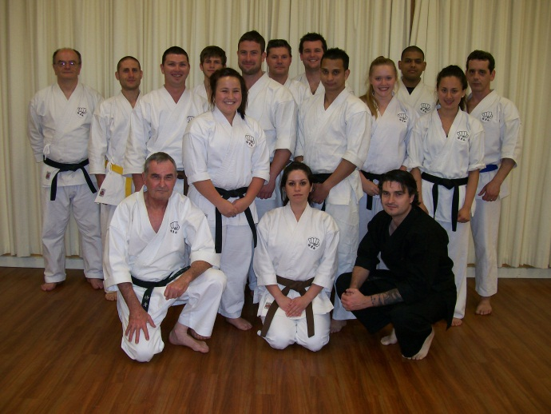

The last class for 2010 at the Hillside dojo.

XMAS DINNER
On December 21st the club held its Annual Xmas Dinner at the Legends Bistro (named after Sensei Lincoln) at the Monee Valley Racing Club. Some 20 or so people attended, and all had a great night!

WEBSITE
Our website Uwww.goju.com.auUTh had a major update and redesign in 2010. The site is one of the best presented martial arts website anywhere, and contains lots of information and articles, as well as a really good photo section. Many thanks to Suraj who developed the site free of charge for us. A great contribution to the club!!! Since we launched the updated site in August we have had: 1,700 hits, which is pretty good for a website for a little karate club in Melbourne!! ! The website was launched in January 1999. Since then the site has received a total of 49,157 visits,

ANNUAL TRAINING DAY 2010
On Saturday, 3rd October we held our fifth Annual Training Day and Competition at Ginifer dojo. Thank you all for attending and helping to make the day enjoyable and productive!! Sensei Lincoln taught a series of empi waza, and Shihan Graeme conducted a practical session on Seienchin kata.
Our Black Belt Grading saw Bridgette Gwynne from the Hillside dojo achieving her Black Belt. Well done Bridgette!!!

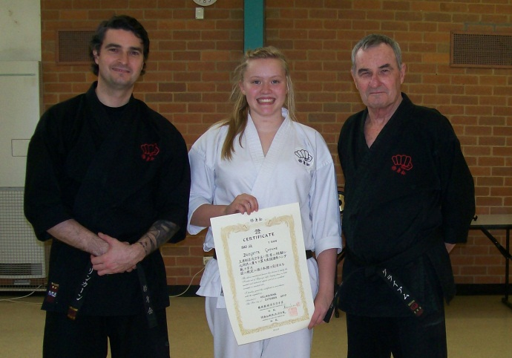
Sensei Lincoln, new Shodan Bridgette Gwynne with her certificate, and Shihan Graeme

In the evening, after the Training Day, all the Black Belts met for dinner at Chiba Japanese Restaurant to help Bridgette celebrate her promotion. Eating a huge piece of wasabi is the initiation all new Shodans go through, and Bridgette was no exception.!!!! The tears running down the face were a sight to see!!!!

Our Shushin Kai Kumite Championship was conducted with great spirit and skills. Adam Blanche from The Tullamarine dojo was the winner again in 2010. and was presented with a plate engraved with his victory! Well done Adam!!! The tournament was designed to incorporate a “grading” or “handicap” system so lower grades and females received higher scores for fighting higher grades, thus giving everybody a fair chance of winning. Also, the sparring was not along based on AKF rules, but on close quarter sparring of 30 seconds duration.

I would like to thank Suraj for arranging lunch/drinks etc. Also Bill, Edwin and Suraj for administering the kumite, and Sensei Lincoln who not only refereed for 2 hours and taught several sessions, but who planned and organised the whole event. Thanks to you all!

The club now has 12 Black Belts:- six 1st Dans, two 2nd dans, two 3rd dans, one 4th dan and one 5th dan.

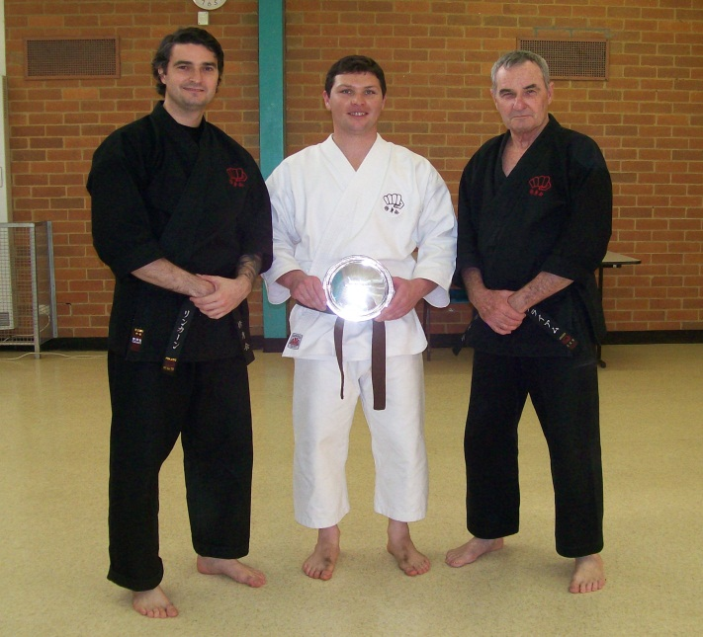

Adam receiving the Championship Trophy with Shihan Graeme and Sensei Lincoln.

VISIT TO JAPAN BY SHIHAN GRAEME
In June Shihan Graeme returned to Japan for 2 weeks to train with Tsubamoto Sensei at the Shigakukan. During this visit Tsubamoto Sensei accepted Shihan Graeme as his direct student and Shushin Kai as a member dojo of Ichikawa-ha Goju-ryu Karatedo Sosui-kai. We now wear the Ichikawa Goju fist on our gi’s along with the club name.
The training on this trip was different from the earlier visit in 2009. Graeme Shihan was told “last time you visited us you came as a guest…..this time you are a student”. That meant…now for the real stuff………. Apart from the usual warm ups, there were more variations in the basics and combinations. Each class focused on detailed instruction and practice of kata and bunkai from each. Sensei gave detailed training in Gekiha, Sanchin, Tensho, Saifa, Sanseiru, Seienchin, Shisochin, and Kurarunfa plus bunkai. Additionally, Shihan trained with Yuki Tsubamoto privately both in the dojo and a park near Yuki’s home.
Fortunately, Sensei permitted Shihan to film the training sessions for personal use only, as did Yuki who filmed katas for Shihan to train with back in Melbourne.
Apart from the training, Shihan spent a few days sightseeing with Ono Sensei who took Shihan for a day trip to Kamakura and Enoshima as well as a whole day exploring Tokyo, visiting the Meiji shrine, Tokyo Tower, Aqua City and Ginza. One night after training Sensei Ono took Shihan to Shibuya to sample the Tokyo night life and bars……..
Yuki Tsubamoto also took Shihan to visit Tokyo Dome City and visited the new Tokaido store.
On other occasions Shihan explored by himself and is becoming quite good at negotiating the Tokyo train system!
On Shihan’s last day in Tokyo, Sensei took the senior students to visit Ichikawa’s grave to pay respects.
That night Shihan Graeme was a guest of Shigaku Kan at a dojo dinner held at a beautiful Japanese restaurant. Much fine food, drink and friendship was the order of the night!!!
Afterwards Sensei’s Yuki Tsubamoto, Ishii and Ohara took Shihan for an after dinner extension, and talking with great laughter until we were invited to “hit the street” because they wanted to close restaurant.

I would like to thank Sensei and all members of Shigakukan for their friendship and instruction.

Sensei also indicated he would welcome a group of Shushinkai students to visit Japan in 2011 to train with Shigaku Kan.

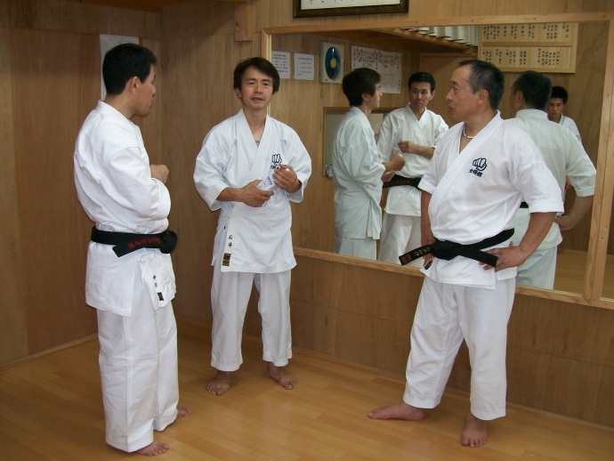
Sensei Ohara, Sensei Ishii and Sensei Tsubamoto after class at the Shigaku Kan dojo.

VISIT TO MELBOURNE BY ISHII SENSEI
Whilst in Tokyo, Shihan was asked by Sensei Tsubamoto to accept Sensei Kazuo Ishii in Melbourne for 3 weeks for the purpose of training Shihan Graeme in all Ichikawa style Goju katas and training with Shushin Kai. Sensei Ishii was to advise Tsubamoto Sensei of our standard and progress in adopting Ichikawa karate. Sense Ishii, 7th Dan, is Tsubamoto Sensei’s most senior student.

Well, Ishii Sensei arrived in Melbourne late June, with no English (except an electronic translator) and stayed at Shihan’s house (with no Japanese spoken). After 3 weeks Ishii Sensei’s English was running hot!!!!!!

Every day for 3 weeks Shihan trained with Ishii Sensei at the hombu dojo, for hours at a time, learning and practicing the katas as performed by Shigaku kan. Every night Sensei Ishii took the Shushin kai classes at Westmeadows, Tullamarine and Hillside. In the hombu dojo there were additional classes for Black Belts and private sessions for Shihan and Sensei Lincoln.

Everybody in Shushin kai were rapt with Sensei Ishii’s visit and enjoyed his instruction immensely!!!

On Sensei’s last night, members of Shushin Kai presented Sensei with a handsome watch to thank him for his visit and teachings.

Sensei Ishii was also treated to sightseeing and some good old Aussie hospitality. During his visit, amongst other things, he visited Sovereign Hill, an historical recreated mining town, went to an Australian Rules football match at Etihad Stadium, and had a sensational night out with the Black Belts at Crown Casino. There was also a Yudansha dinner at Chiba Japanese Restaurant, a trip to Frankston, a walking tour of Melbourne city and a day visiting Melbourne beaches.

As a result of Sensei Ishii’s visit, Shihan Graeme and all Shushin kai students were able to consolidate and extend their knowledge of Ichikawa karate.

The way was paved for Shushin Kai Black Belts to visit Japan in 2011.
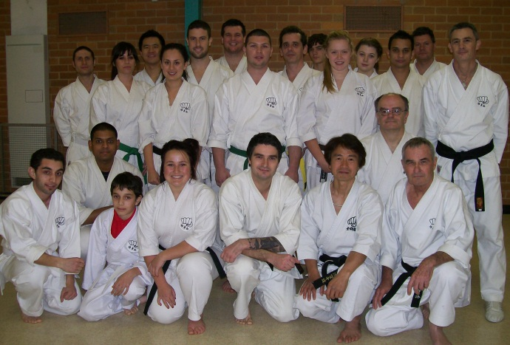
Sensei Ishii and Shushinkai students at the Ginifer dojo on the last night of his visit..

VISIT TO JAPAN 2011
In May 2011, senior Shushin Kai Black Belts will be visiting Japan to train with Tsubamoto Sensei at Shigaku Kan. Lots of fundraising and extra events have been in place for some months now, and the group going to Japan are attending 15 extra training sessions at the hombu dojo.

VISIT TO SHUSHIN KAI BY YUKI TSUBAMOTO
Yuki Tsubamoto, 4th dan is a nephew of Sensei Tsubamoto. He has accepted our invitation to visit Melbourne this year to train with Shushin Kai. The tentative plan is for him to visit us at a time to enable him to attend our next Training Day and Black Belt Grading. When the dates firm up, Members will be advised.

IMPORTANT NEWS : FEES
This year there will be a slight increase in adult training fees, brought about by an increase in all dojo rents. This is the first fee increase for 5 years. The new fee structure will be advised to Members separately.
Would all members please pay their fees promptly on the FIRST training night of each month. (Which means of course, bring your fees to the first night back in class).

PAYING FEES
We accept cash or cheque for any fees. You can also pay your fees via direct banking on the internet.
We bank with Members and Education Credit Union
BSB 803-140
Name of Account: Japanese Karate Academy Inc.
Account Number: 14069239
When making payments please add a description (ie Membership Fees), and send Shihan a short email (sensei@primus.com.au ) saying you have made the payment.

2011 CLASSES START DATES

Hillside Dojo (Banchory Ave, Hillside): Tuesday 1st February at 7.00pm.

Ginifer dojo (Carrick Drive, Gladstone Park) Wednesday, 2nd February. At 7.00 pm

Westmeadows Dojo (Raleigh St Westmeadows): Monday, 7th February at 7.15 pm

THE YEAR AHEAD IN SHÚSHINKAI
I am looking forward with great anticipation to seeing you all when class recommences. I am sure 2011 will be exciting and productive for everybody!!!

A trip to Japan, a visit from Yuki Tsubamoto, and more Black Belts are in our sights!!!!

See you back in class………..

Shihan Graeme
Jan 2011

