SHÚSHIN KAI GOJU RYU KARATE

JANUARY, 2024 No. 36

kiai !!!!

THE 2023 YEAR
Classes resumed as usual this year and everything went well except for a hiccup with our Hillside dojo at Banchory. More news about that later in this newsletter.
We welcomed a number of new students this year, and we hope you continue to enjoy your karate journey with us. As usual however we had the drop-in visitors who never came back, and several members who had to leave us due to work or family circumstances.

GRADINGS
Our last night of training for 2023 was, as usual, held at the Hillside dojo as a combined class for all members. During this last class we held a grading for kyu grade students and below are the results. Everybody did a great job and showed their progress in their karate journeys. The katas demonstrated were of a very good standard and the kumite was very spirited! We were pleased to see Brown Belts be awarded to Jacqueline, Austin, Noor, and Jagreet. Now your hard work really begins, so get ready!!!!

The Kyu grading results ;-

Promoted to 3rd Kyu Brown Belt
Austin Suban Somarathna (Hillside)
Jacqueline Scheicher (Hillside)
Noor Sani (Hillside)
Jagreet Ganda (Hillside)

Promoted to 4rd kyu Kyu Green Belt
Thai Nguyen (Hillside)

Promoted to 5th Kyu (Blue Belt)
Ishaan Brar (Hillside)

Promoted to 6th Kyu (Orange Belt)
Khang Nguyen (Hillside)
Raunaq Saini (Hillside)

Promoted 9th Kyu (White Belt with stripe)
Remy Huynh (Hillside)
Danielle Messih (Hillside)

New belts and Certificates will be awarded on the first night back in class in 2024 so be there !

BLACK BELT GRADING
On our Annual Training Day, which is held on the first Saturday of October each year, we promoted two more members to 1st Dan (Shodan) Black Belt.
After years of study, practice, ups and downs, and covid restricted training, Sanindul Somarathna and Gabriela Stojkposka from the Hillside dojo achieved their coveted Black Belts.. Congratulations to you both!!!

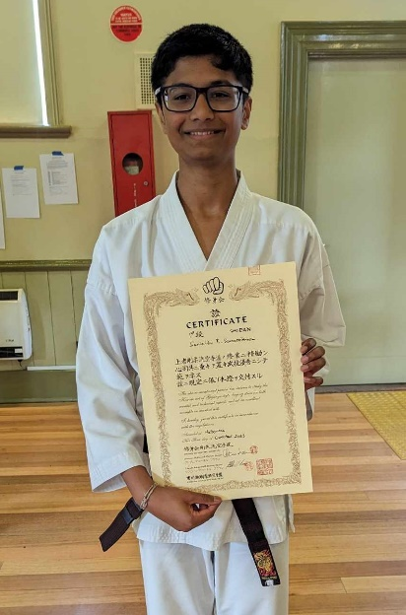
Here is Sanindu after receiving his Shodan Certificate and new Black Belt

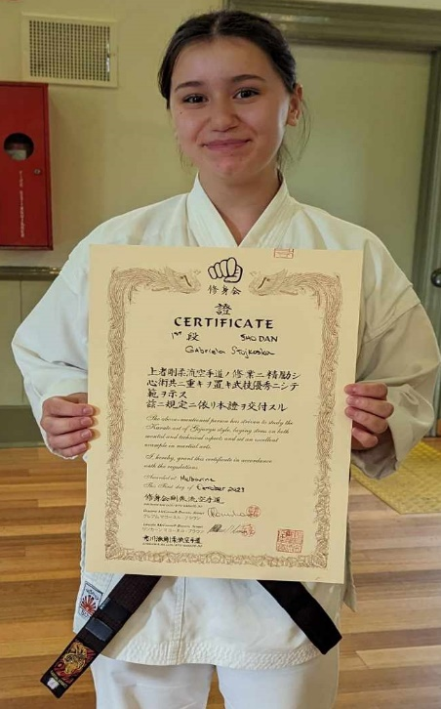
Here is Gabriela after receiving her Shodan Certificate and new Black Belt.

The kumite part of their grading was judged from their performance during our kumite competition in which every member competes in kumite against every member of the club.

At the grading their assignment “What Karate Means to Me” was read to all members. This assignment was accepted and can now be viewed on our website. It is also reprinted at the end of this newsletter. We recommend everybody read both Rishen and Gabriela’s assignments for a good insight into their journey from White Belt to Black Belt!!!

We also had a Dan Grade promotion in which Steve Afflitto and Nathan Daws from the Westmeadows dojo were promoted to Nidan (2nd Dan) They took an active role by competing in the Kata Tournament as well as demonstrating their grade kata. Steve went on to win the Club Kumite Championship as his kumite part of the grading test.

LAST NIGHT OF TRAINING 2023
As is our usual practice we brought the Westmeadows and Hillside dojos together for our last night of training for the year. We also held our kyu grading. This year we were much better with our timing and actually finished class on time!!!.

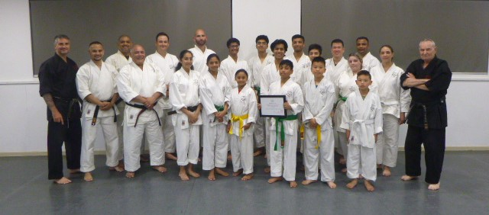This pic shows the class at the end of 2023

STUDENT OF THE YEAR AWARD
Every year we nominate one student to be awarded our “Student of the Year” award. This year we were happy to present this award to Austin Suban, 4th Kyu. from the Hillside dojo. Suban has trained hard all year and shows great promise that he will grow into an excellent Black Belt in the future. Suban also gained his 3rd Kyu Brown Belt. Well done!!. Keep up the good work and continue to enjoy your karate journey!!

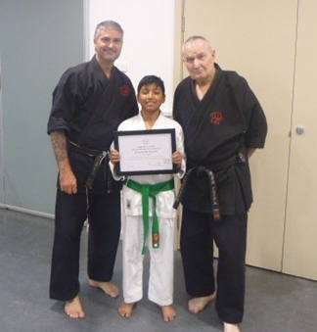Here is Austin receiving his “Student of the Year“ award for 2023.

2023 TRAINING DAY
Our 19th Annual Training Day was held on the first Saturday in October at the Westmeadows dojo with a very large group attending this year. Special subjects were covered including the introduction of the kata Naihanchi Nidan, how to defend from the bow position and completion of the 20 intermediate sparring method applications. For just the second time this year we included a kata tournament in which all members participated. The Ichikawa Memorial Kata Tournament trophy was presented to 1st Kyu, Rishen Somarathna who completed an excellent demonstration of two kata and also graded to Shodan later in the day.
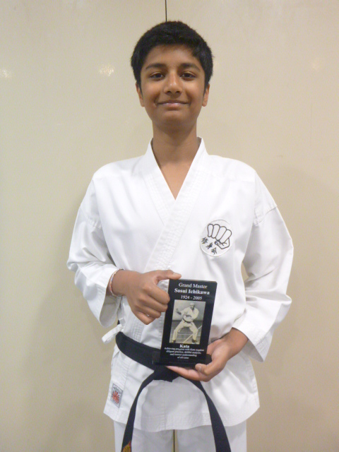
Here is Sanindu holding the Ichikawa Memorial Trophy for Kata.

Then we held the Annual Kumite Tournament which once again proved to be a nail-biting event. The eventual winner was Stephen Afflitto, 1st Dan, from the Westmeadows dojo. This is Steve’s second straight year of winning the trophy. Well done Steve!!! One more win and you’re out!!!
As winner, Stephen was once again presented with the winners Championship plate to keep and also the Ichikawa Memorial Trophy for kumite.
The kumite tournament was conducted safely with no injuries, except Chan decided a low kick to Thai would be a good idea. Thai blocked in true goju style by lifting his leg. As a result Chan suffered a toe injury which caused him to withdraw from the tournament. Everybody tried very hard to produce their best kumite skills, and everybody including the juniors exhibited good control, and great spirit. The competition was enjoyed by all and required each member to fight everybody in the dojo. Sensei Lincoln’s scoring system gave bonus points to lower grades and females, and this gave everybody an equal chance of winning the tournament.
Jagreet Ganda from the Hillside dojo performed excellent kumite and despite the use of the handicap system in favour of kyu grades and females, won the Junior Kumite Champion medal. Well done and congratulations to Jagreet!!!
The highlight of every Training Day is our Dan Grade promotions. Sanindu has studied and practiced hard over the years, including during Covid lockdowns. He kept focus and is warmly welcomed into our Yudansha ranks as was Gabriela Stojkposka who has demonstrated significant commitment over a long period of time and equally deserves the success.

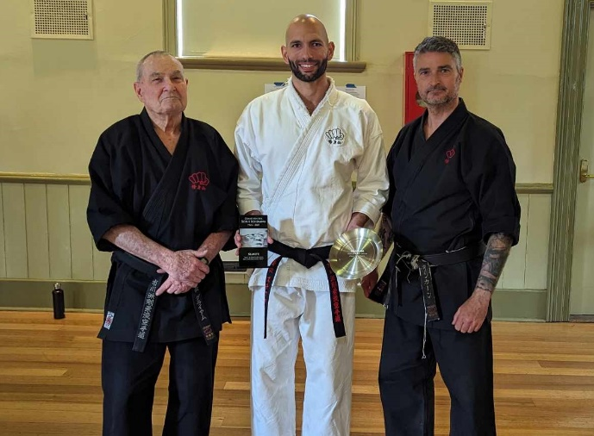
Stephen Afflitto is pictured here, holding the Ichikawa Memorial Trophy for Kumite, and the Shushin Kai Club Champion trophy.

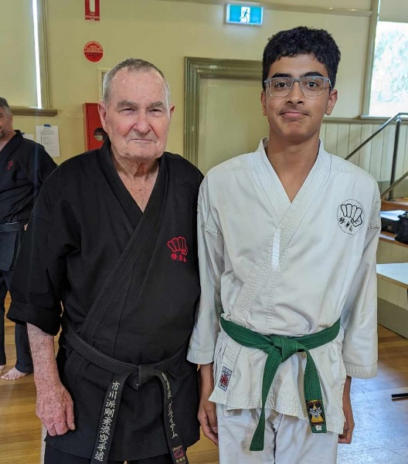
Jagreet Ganda from the Hillside dojo won the Junior Kumite section of our tournament and was presented with a medal for his excellent performance.
l
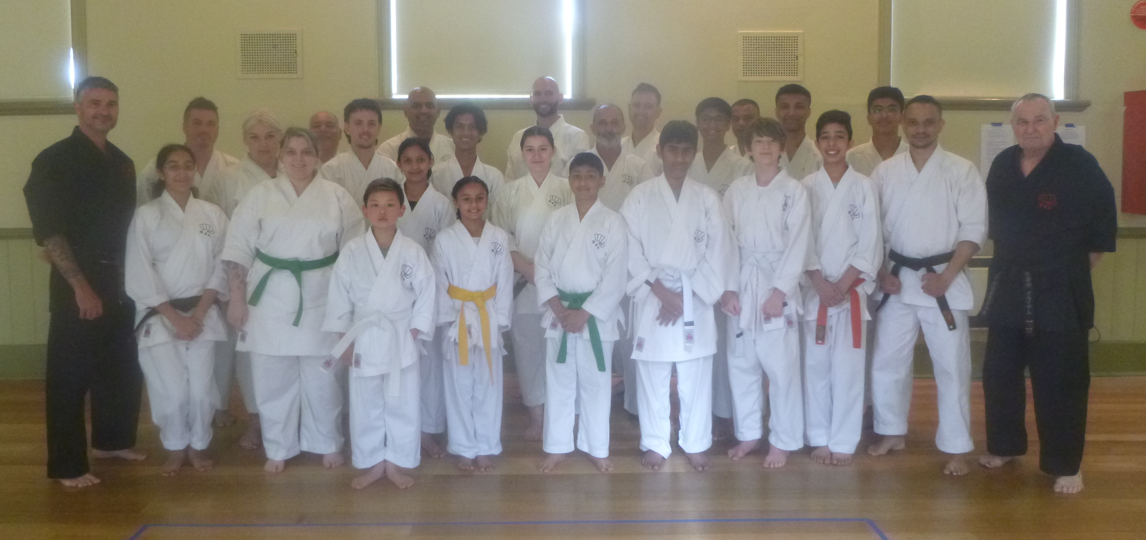
This is our group after our Training Day

THE JOURNEY AHEAD
This year Sensei Lincoln and I continued intensive advanced study under Sensei Chris Clifford. We have Zoom classes every 2 weeks with Chris and his disciples in England, and additionally Shihan Graeme speaks with Chris every couple of days, and have one on one lessons with him on Zoom and Whatsapp.

Just recapping that Chris is a 5th generation Bubishi recipient from his Master, Ichikawa Sosui Sensei. Chris began studying under the guidance of Ichikawa Sosui Sensei in 1972 visiting Japan on many occasions over a 33 year period until his passing in march 2005. Chris sensei was awarded his 7th dan in 2002 by Ichikawa Sensei.

Chris Sensei is the first and only westerner to receive the "Bubishi" directly from the 4th Generation Grand Master and Custodian of "Bubishi", Ichikawa Sosui Sensei. Chris Sensei visited Japan up to 5 times a year to train with Ichikawa Sensei, and has the deepest understanding of Ichikawa Sosui Sensei's studies. Chris is able to pass this knowledge on to his students and to us because he is English and therefore there are no translation and interpretation issues. Ichikawa Sensei also entrusted Chris with important books and copious notes of his studies which have now been translated for the benefit of Chris’s students and other students of the martial arts. In this way, Ichikawa Sosui Sensei’s knowledge and studies can be passed to this current generation.
These documents have now been published on Chris’s website for any interested people to read for free, as a gift to all karate students world-wide. This is done to ensure Ichikawa Sensei’s research and teachings are gifted to the world. You are encouraged to go to Sensei Chris’s website!!!
Chris’s website is:

www.chriscliffordgojuryu.com

Ichikawa sensei only taught personally all he studied and developed. The teachings were only face to face, to a select number of disciples of senior Dan grade. Ichikawa sensei developed his karate by practicing with his senior disciples who stayed with him throughout his teaching career. So one must have a teacher fully conversant with all of Ichikawa’s teachings to be able to understand the full content .

VISIT TO MELBOURNE BY SENSEI CHRIS
We are delighted to advise you that Chris Clifford Sensei has kindly accepted our invitation to come to Melbourne!!! Chris and his wife will be visiting us from 6th to 17th March.
During his stay, Chris will be working with both Shihan Graeme and Sensei Lincoln, to extend our knowledge and understanding of the highest levels of Ichikawa Sensei’s karate. Chris will also conduct special classes for our Black Belts (which all Black Belts will be expected to attend). Chris will also attend all our evening classes at both the Westmeadows and Hillside dojos.

“Ichigo-iche” means “once in a lifetime”. For all of us this is a once in a lifetime opportunity to study and train with one of Ichikawa Sensei’s most senior disciples. Chris never left Ichikawa’s dojo Sosui Kan as almost everybody did over the years. He is a direct descendant and inheritor of Ichikawa sensei’s karate. He was a pall bearer at Ichikawa Sensei’s funeral and it is very fitting that Chris will be at Hillside dojo on the 19th anniversary of Ichikawa sensei’s passing.
Many schools and teachers of Goju Ryu karate claim lineage in Ichikawa karate, but in truth they do not have this direct lineage at all. It is very fashionable to claim Ichikawa lineage but in most cases they claim the lineage falsely, for marketing and self-promotion reasons.
During Chris’s visit we will be taking Chris and his wife to visit sight-seeing attractions in Melbourne/Victoria and there will be several dinners arranged for Black Belts to attend.
It would be appreciated if all members make every effort to meet, train with and experience Chris Clifford karate. There will be no public events so Chris will spend all his time with us.

OUR HILLSIDE DOJO RELOCATION
At the end of July last year we were advised by Melton Council that there was a safety problem with Banchory Community Centre. It seems a wall in the Centre has separated from the roof. It turns out that the wall in question is the wall in the room we use - the wall with the mirrors.
With Banchory closed, there was a mad scramble to find us new, temporary premises.
The Council was able to organize two new venues - Hillside Community Centre, in Royal Crescent, Hillside on Tuesday nights and Parkwood Green Community Centre on Thursday nights. Interestingly, Hillside Community Centre was the site of our first dojo in Hillside after we closed down our previous dojo at the Coburg West Primary school. Back in the year 2000, Hillside Community Centre was a single small room, but was later extended to include the large room we used as our dojo. A few years later Banchory Community Centre was built and Council asked us to move there and be the first tenant. The mirrors were put into the Kororoit Room especially for us,
We have been at Banchory Community Centre ever since until this latest problem.
So we shifted venues which suited some but not others so much. The Parkwood Green venue although large, had a bad floor which was very slippery, and always in need of a good clean which we could not give it apart from a sweep with a couple of small brooms.
Hillside Community Centre was a larger room, with better access, and a better floor which was not slippery but posed the same cleaning issues.
Anyway, we survived and we are still here!!!
Unfortunately, there has been little or no work done on Banchory, and our return has been delayed several times. We have now been informed that April this year will be the earliest we can hope for to return to Banchory. It may well, and probably will be longer.
As a result, we will be remaining at the Hillside Community Centre for the foreseeable future. Fortunately though, we will be at Hillside on every Monday and Thursday nights from 7pm to 9pm. We will no longer be using Parkwood Green. Unfortunately for Remy he will probably not be able to ride his bike to class due to distance and road safety.
The dojo changes have been made to our website and hard copy literature.

CLEANING DOJO FLOORS
Just a quick note about the floor situation at Hillside and later back at Banchory. The same people who come to class early always sweep the floor. Those who come late would not even know that this has been done for them.
In karate culture it is an obligation that the dojo floor is swept and cleaned before/after every class, and this is done as a group responsibility. We have asked for extra brooms at Hillside and would all members please come to class in enough time to help with the cleaning of the floor and not leave it always to others. The Westmeadows dojo is always swept by members and the hombu dojo is cleaned by me.

SENSEI LINCOLN’S MESSAGE
It would appear that the COVID experience is now behind us as we have not had any interruptions to our classes throughout 2023 due to the dreaded “Rona” !

This year has seen a strong continuation the the significant extension of our karate knowledge through the kind mentoring of Sensei Chris Clifford. To date, our senior students are enjoying the benefit of this knowledge as your instructors continue to learn and develop the schools Goju Ryu in line with Master Ichikawa’s teachings.

The training day was another highlight for the year and a huge congratulations for everyone who participated, won, lost, passed dan grading tests and learnt on the day. Please revisit your notes and continue to practice those key items learnt on the day.

It is important to note that moving forward and for the sake of formality, anyone attempting any dan grade is required to demonstrate kata as traditionally required as well as participate in the kumite tournament (as the tournament is the “kumite” aspect of the grading). This is irrespective of age or gender.

Our school is about kumite.

IMPORTANT NEWS: FEES
Once again, this year there will be no increase in training fees or Membership Fees. Our monthly training fees have not increased for 13 years, and the time before that was 5 years.

Please note that Monthly Training Fees are payable EVERY month except January. We do not charge extra fees when there are 5 weeks in a month, or give discounts for part months such as December. We have been able to keep our fees low by doing this. If Members do not want to follow these arrangements, then we will put our fees up. We know that other karate organisations charge up to double what we charge, and their classes are full of students, making for large profits. We are a not-for-profit club and therefore we can keep our fees low.

As a reminder, this is our fee structure:

MEMBERSHIP FEES & PERSONAL MARTIAL ARTS INSURANCE (GST included)
The Annual Membership Fee is payable on joining and is renewable annually.
Annual Membership All ages $80

TRAINING FEES) based on juniors being under 12 years, and adult fees applying 12 years and over.
Monthly Training fees
Juniors $65
Seniors $70

Please note the monthly fees for juniors aged 9 years to 11 years inclusive is $65 per month, NOT $60.

Would all members please pay their fees promptly on the FIRST training night of each month. (Which means of course, bring your fees to the first night back in class).

We require monthly fees to be paid promptly each month, not dragging out non-payment for weeks on end and requiring reminders to be sent out. It is YOUR responsibility to pay your fees on time.

PAYING FEES
We accept cash or cheque for any fees. You can also pay your fees via direct banking on the internet.
We bank with BANKAUSTRALIA
BSB 803-140
Name of Account: Japanese Karate Academy Inc.
Account Number: 14069239

When making payments please add a description (i.e. Training Fees), and send Shihan a short email (shushin@bigpond.com) saying you have made the payment.

2024 CLASSES START DATES

Hillside Dojo (Hillside Community Centre, Royal Crescent, Hillside):
Thursday, 1st February at 7.00pm.

Westmeadows Hall Dojo (Raleigh St, Westmeadows):
Monday, 5th February at 7.00 pm

Westmeadows Hombu Dojo
Wednesday 7th February at 7.00pm.

COMINGS AND GOINGS
As is usual in martial arts there was the usual comings and goings throughout the year.

We received a large number of student enquiries, mainly from our internet presence, but most people are “shopping” only. A few came to class and left after seeing the karate we practiced. Some stayed for a few lessons. By far the majority of enquiries were from parents looking to have their children join the club. But these enquiries generally were for children aged between 4 years and 7 years.
We have a minimum age of 9 years to join Shushin Kai.

However, a few stalwarts joined us and continue to practice. Welcome!! I hope you continue to enjoy your journey with us.

We look forward to everybody enjoying and progressing their karate. The year ahead will be positive!!!

I am looking forward to seeing you all back in class ………..

Graeme McConnell-Brown
Kaicho, Shushin Kai Australia
11 January, 2023

This is Gabi’s Black Belt assignment.

What Karate Means to Me
Before I started karate, I didn’t know one thing about self-defence or anything about karate itself. I would always fight my sister for no reason around the house and it would end in my sister getting in trouble. Because I would start arguments and get upset without defence, my parents and sisters thought I was a little aggressive. As a result, with the help of my parents I decided to pursue karate to finally learn about self-defence and help cope with my feelings.
So that’s when my parents suggested that I should start karate and think about how it would benefit me throughout the years. They told me that there was a karate school happening around the corner of Hillside, so then I tried out and started to begin that journey of my life. The first time I started, nothing made sense. I didn’t know what anything was – the technique, the words, what to do with my feet and hands – didn’t know anything. My face would turn red, and I would feel scared because I didn’t know anyone, and I didn’t know what to do.
My dad kept telling me that when he was little, he always wanted to go and experience the different aspects of karate, but he couldn’t because they didn’t have enough money, so I thought I could take on that journey and make him happy and so I did. He thought karate would make me strong, independent, and not be so aggressive. He kept giving me lectures on some nights when we have dinner and would tell me stories about him and would tell me everything about karate about how you have to be fast and calm and have to be ready in action if something happens. He was right. From that point on, he still gives me lectures and still tells me the same stories over and over again.
As the months went by, karate made me understand what the sport means and opened up a new meaning of it to me. The sport helped me build my resilience and excel in what I do. However, karate is not only just a sport, but also more about the art form that includes precise techniques and the focus on form and posture, and it’s like a dance that requires discipline and self-expression. I’ve now learnt not to take my mistakes as something horrible, but rather as something to grow and learn from. Without mistakes, I wouldn’t be able to know the meanings, the techniques and how it could be useful in the real world so with that, it has helped me through a lot of ways, even helped me with swimming and traditional dancing.
Karate has made a huge difference in my life. It made me feel like I’m a better person, it made me feel stronger and more independent, and it made me have more confidence in myself than I did in the past. This is because the past 4 years, I was just a 12-year-old girl who was scared of doing anything in front of my peers, but now karate made me who I am today.
Receiving a black belt means taking responsibility of my actions, taking responsibility of teaching new knowledge to kids, and taking responsibility to understand different meanings and different techniques, so I can understand what it means to be a black belt. I don’t know what is going to happen in the future, but I know I am going to continue this journey onwards and know the different aspects of karate from which I still need to learn.
By Gabriela Stojkoska on 7th October, 2023
Gabriela Stojkoska began training at Shushinkai karatedo on 5th March. 2019, at age 11 years. She was graded to Shodan on 7th October 2023, at age 15 years

This is Sanindu’s Black Belt assignment
What Karate Means to Me
Karate is a testament of the person that I was, the person that I am, and the person that I can be in the future. It symbolizes my journey from ignorance to knowledge, from weakness to strength, and from fear to courage. To put it simply, the way I see it, karate is akin to an organ. Limiting it, by either regularly skipping classes or not paying attention will cause it to deteriorate into an unsalvageable mess. However, if you nurture it; constantly questioning why or how something works and actively playing a role in its development, it will become so much more effective.
Physically, karate has made me fitter and healthier than ever before. Mentally, it has sharpened my focus and deepened my resolve. Spiritually, it has introduced me to the profound concepts of Zen, meditation, and chi-kung, which have calmed my mind and nurtured my inner peace. The holistic transformation has returned immeasurable value to my life. However, physical capabilities are only one aspect of the whole picture that is karate; it is a transformative process that moulds character. Karate has instilled in me humility, respect, and resilience. The respect for my sensei and fellow practitioners has taught me the value of humility, while the constant pursuit of perfection has fortified my resilience in the face of life's challenges.
Karate has illuminated the connection between effort and success. The lessons learned on the dojo floor apply seamlessly to life. Hard work, dedication, and continuous self-improvement are the keys to progress. Moreover, karate has exposed me to a diverse community of students, reinforcing the idea that strength comes in many forms and from various backgrounds. It has shattered stereotypes and fostered a deep appreciation for the uniqueness of everyone. My future is a canvas upon which I intend to paint the wisdom, strength, and tranquillity I have acquired through karate. I see a life filled with challenges I am better equipped to face, goals I am more determined to achieve, and relationships I am more capable of nurturing. The future holds a path illuminated by the principles of karate and guided by the serenity of Zen.
Karate has altered my perceptions of the world, people, and most importantly, myself. It has taught me that the world is a place of constant change, where adaptability is key. People are complex and multifaceted, and true understanding comes from embracing diversity. Most significantly, it has unravelled the depths of my own character, making me acutely aware of my strengths, weaknesses, and potential for growth.
Through karate, I have embarked on a journey of self-discovery. I have learned to confront my limitations, face my fears, and strive for excellence. Role models within the martial arts community have shown me that the pursuit of greatness is an ongoing process, and the black belt is not an endpoint but a milestone in a lifelong journey of self-improvement. Karate has helped me crystallize my purpose in life. It is to continually seek personal growth, to inspire others on their journeys, and to contribute positively to my community. It is about being a role model, not just on the dojo floor but in the broader arena of life.
By Sanindu Somarathna on 7th October 2023
Sanindu Somarathna began training at Shushin Kai karatedo on 1st September, 2018 at age 10 years. He was graded to Shodan on 7th October 2015, at age 15 years.

