SHÚSHIN KAI GOJU RYU KARATE

JANUARY, 2012 No. 23

kiai !!!!

2011 BREAKUP & GRADING RESULTS
A successful Breakup night was held at the Hillside dojo on 15P^{thP} December.

Grading results, in no particular order …………………

Promoted to 3rd Kyu Brown Belt
Christopher Vella

Promoted to 6th Kyu Orange Belt
Laura Soteriou

Promoted to 9th Kyu
Eric Stavros-Maximos
Phillip Andreou

New belts and Certificates will be awarded on the first night back in class.

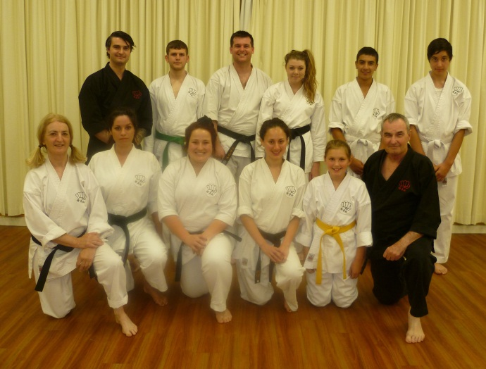
The last class for 2011 at the Hillside dojo.

XMAS DINNER
On December 20th the club held its Annual Xmas Dinner at the Legends Bistro at the Moonee Valley Racing Club. Some 20 or so people attended, and all had a great night!

STUDENT OF THE YEAR
The prestigious “Student of the Year” award for 2011 was awarded to Laura Soteriou from the Hillside dojo at our last night of training for 2011. Laura has tried consistently throughout the year and has always trained twice a week come rain or shine. As a young, enthusiastic karateka, Laura is a great role model for young people in karate. Well done for your efforts Laura!!!

WEBSITE
Our website Uwww.goju.com.au continues to present our club to the public. Over the past 12 months we have had 4,035 visits, which is pretty good for a website for a little karate club in Melbourne!! The original website was launched in January 1999. Since then the site has received a total of 53,192 visits,
Many thanks to Suraj as administrator,

ANNUAL TRAINING DAY 2011
On Saturday, 8th October we held our sixth Annual Training Day and Competition at Ginifer dojo. Thank you all for attending and helping to make the day enjoyable and productive!! Sensei Lincoln taught an intermediate level of Kamae Kumite and how to perform the opening Kamae movement of all our kata, utilizing, envelopment, me no ichi , bowing and zanchin. Shihan Graeme taught the kata Naihanchi Nidan which we require to know with our affiliation to Shigaku Kan in Japan.
Our Black Belt Grading saw Adam Blanche, Kimberley Johnson and Paige McDowell achieve Black Belt. Well done to the three of you!!!
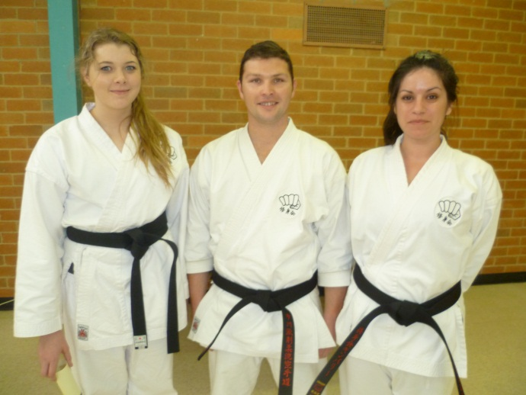
Paige McDowell, Adam Blanche and Kimberley Johnson with their new black belts.

In the evening, after the Training Day, all the Black Belts met for dinner at Chiba Japanese Restaurant to help Paige, Adam and Kimberley celebrate their promotion. Eating a huge piece of wasabi is the initiation all new Shodans go through, and these three were no exception!!!

Our Shushin Kai Kumite Championship was again conducted with great spirit and skills. Adam Blanche from The Tullamarine dojo was the winner again in 2011, equaling Edwin Ten’s record and was presented with a plate engraved with his victory! Well done Adam!!! The tournament was designed to incorporate a “grading” or “handicap” system so lower grades and females received higher scores for fighting higher grades, thus giving everybody a fair chance of winning. Also, the sparring was not based on AKF rules, but on close quarter sparring of 30 seconds duration.

Once again, thanks to Suraj for arranging lunch/drinks etc. Also Vicki, Edwin and Asanka for administering the kumite, and Sensei Lincoln who not only refereed for 2 hours and taught several sessions, but who planned and organised the whole event. Thanks to you all!

The club now has 13 Black Belts:- Eight 1st Dans, one 2nd dan, two 3rd dans, one 4th dan and one 5th dan.
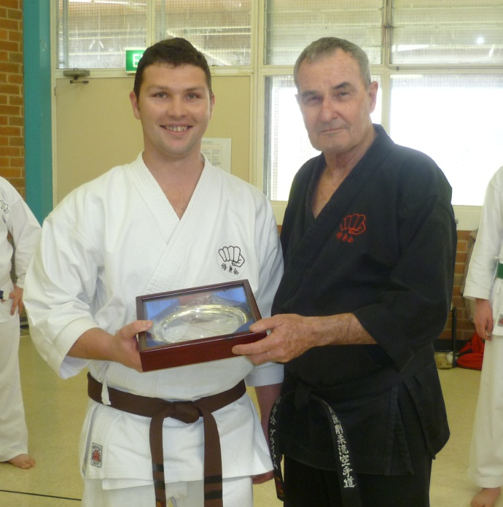
Adam receiving the Championship Trophy from Shihan Graeme

VISIT TO JAPAN BY SHÚSHIN KAI
Late in 2010 plans were made or all our senior Black Belts to visit Japan as a group. Unfortunately a number of circumstances conspired to reduce this number to 3. In May, Shihan Graeme, Vicki Katte and Suraj Fernando travelled to Japan to train with Tsubamoto Sensei for 2 weeks at the Shigakukan.
I have asked Vicki and Suraj to write a short report on their experiences with the visit, and these are included at the end of this newsletter.
I would like to thank Sensei and all members of Shigakukan for their friendship and instruction.

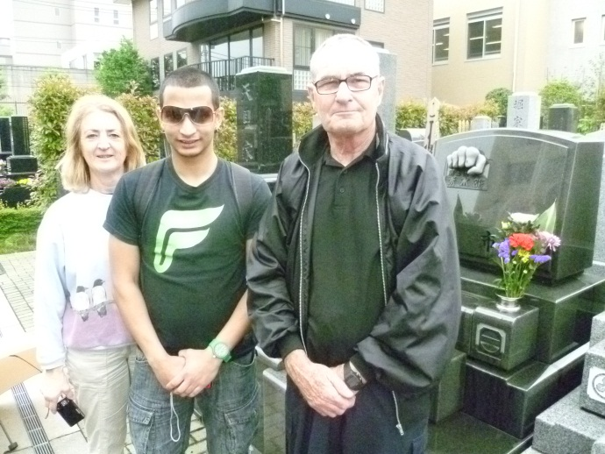
Vicki, Suraj and Shihan Graeme at Ichikawa Sensei’s grave .

PENDING VISITS TO MELBOURNE
We have formally invited Sensei Tsubamoto and Yuki Tsubamoto to visit us in Melbourne next year. We are looking forward with great excitement to his visit and hope that he will be able to come. We will keep members updated with news.

We may also be visited by Sensei Daniel Tennent , 5th Dan, from Inyo-Ryu in England. Daniel is well known to our senior Black Belts, and has indicated he is actively planning to visit us.

VISIT TO JAPAN 2012
It is planned for Shihan Graeme to visit Japan again this year. Details will be advised when plans firm up.

SPONSORSHIP
To raise money towards supporting the planned visit of Tsubamoto Sensei to Australia, members of our club have been busy fundraising. Our major effort was a successful chocolate drive. Thank you to everybody who supported us. However this alone is nowhere near enough to pay for the trip so Peter Soteriou came to our rescue. His company, Golden Windows has kindly donated enough money to pay for Sensei’s visit. We are all deeply indebted to Golden Windows for this support.

IMPORTANT NEWS : FEES
This year there will be no increase in training fees or Membership Fees.,
Would all members please pay their fees promptly on the FIRST training night of each month. (Which means of course, bring your fees to the first night back in class).

PAYING FEES
We accept cash or cheque for any fees. You can also pay your fees via direct banking on the internet.
We bank with BANKMECU
BSB 803-140
Name of Account: Japanese Karate Academy Inc.
Account Number: 14069239
When making payments please add a description (i.e. Membership Fees), and send Shihan a short email (sensei@primus.com.au ) saying you have made the payment.

2011 CLASSES START DATES

Hillside Dojo (Banchory Ave, Hillside): Thursday 2 February at 7.00pm.

Ginifer dojo (Carrick Drive, Gladstone Park) Wednesday, 1 February. at 7.00 pm

Westmeadows Dojo (Raleigh St Westmeadows): Monday, 6 February at 7.15 pm

FROM SENSEI LINCOLN
2011 was a year of consolidation for Shushin Kai and will be remembered essentially for a number of key reasons.

Firstly, we conducted our annual Shushin Kai training day. A special thank you to everyone who supported this annual event. It has become a key fixture in our year and one to which we all look forward. Importantly, a dan grading was conducted on this day and as a result, we welcomed Adam, Kimberley and Paige to the black belt ranks. On behalf of all at Shushin Kai – congratulations and now the training really starts !

Also, 2011 saw the first visit of a Shushin Kai touring party to Japan when Shihan travelled to the land of the rising sun with Suraj and Vicki. They would all have received insight and experience that we can only imagine, and no matter how much they try to share in the experience, nothing could compare with actually being there. Thanks to the efforts of Shihan (and to a lesser extent the 2011 touring party), Shushin Kai has been able to secure a martial arts future and friendship with our brother and sister karateka in Japan – something many clubs can only dream of. Coupled with our ties and friendship with Taiani Sensei in New York, our club is now in the enviable position in that we have a tangible and significant links to Japan and New York. Shushin Kai is a small club now playing on the world stage!

2011 has been a difficult year with many interruptions for all of us – illness, family, school, work matters, changing priorities and the like. However, one thing remains constant - these types of issues have been, are and always will be a part of life. Let’s make sure that through all the difficulties, our fitness, health and Shushin Kai remains a significant part of our lives.

With a pending visit from Tsubamoto Sensei at some stage this year, let’s all start today and make 2012 one to remember.

MEMBERS HEALTH
During the year four of our members were hospitalized for treatment of ailments. We missed them very much, and hope that they are now fully recovered!!

COMINGS AND GOINGS
As is usual in martial arts there was the usual comings and goings throughout the year.

We received a large number of student enquiries, mainly from our internet presence, but most people are “shopping” only. A few came to class and left after seeing the karate we practiced. Some stayed for a few lessons. By far the majority of enquiries were from parents looking to have their children join the club. But these enquiries generally were for children aged between 4 years and 7 years. We have a minimum age of 9 years to join Shushinkai.

However a few stalwarts joined us and continue to practice. Welcome!! I hope you continue to enjoy your journey with us.

THE YEAR AHEAD IN SHÚSHINKAI
I am looking forward with great anticipation to seeing you all when class recommences. I am sure 2012 will be exciting and productive for everybody!!!

A possible visit from Tsubamoto Sensei and Yuki Tsubamoto, and more Black Belts are in our sights!!!!

See you back in class………..

Shihan Graeme
Jan 2012

REPORT ON TRIP TO JAPAN

JAPAN TRIP 2011 by Suraj Fernando (Nidan)
Go hard ‘cause you can't go home - Japan 2011!
I was lucky enough to be given the opportunity to travel to Japan with Shihan and Vicki in May 2011 to train with Sensei Tsubamoto and the Sensei's in Japan. I guess it's not often in your life you are given the opportunity to train with the Grandmaster of your style. As most of you know, it was a tragic lead up to the trip to as Japan suffered one of its greatest natural disasters of all time with the tsunami that hit in March 2011. It was very humbling to think that the Japanese were still welcoming our club Shushin Kai to train with them even after such an event, which affected many of their friends and family.
Please find below my accounts from the three different aspects of the trip, The Training, The Sites and most importantly The Parties.

The Training
It was 11 days straight of training. I think I trained more in 11 days than I did the entire year. (That’s correct…..Shihan). It is amazing how your standard lifts and how your body responds when it has to.
The training received was unbelievable... one morning we had to wake up and get to Sensei Tsubamoto’s house at 6.30 after 3 hours of training the night before. We were lucky enough that day to get a lift home from Sensei Tsubamoto which was a real treat. By 9 am that morning I had already trained for 2 hours.

Most of the classes were at Sensei Tsubamoto's house. The dojo was about 3/4 the size of Shihan's dojo. The classes consisted of a lot of basics and there were a few classes where Sensei would sit up the back and watch us train. Basically my punches, blocks, kicks and basics were crap so I copped a hiding. If you did something wrong they would show you how to do it properly by demonstrating the technique on you. Not as funny as it sounds. The classes were about 10 people at a time. Pretty impressive when you are training with a 10th dan, two seventh dans, a couple of fifth dans and a few fourth dans. Nothing can really prepare you for the intensity of the classes... even pre-Bundeena training wasn't this hard or intense. To be honest I loved it... you would wake up every day pumped for the day of training ahead. Sensei Tsubamoto even gave us extra training sessions, which we couldn't refuse... even if we had to get a bus that morning at 10am to go sightseeing.

One Sunday Sensei Ishii taught me Seisan... which I have on video in the mirror while Shihan was learning Superinpai from Sensei Tsubamoto! That day Ishii san demonstrated the Seisan jump punch on my guts... I was unable to go to the bathroom properly for a couple of days after that. I now know why they call it the killer punch! From that Sunday onward I had a few lessons on Seisan and we had to demonstrate our kata on the last day of training. To me this was like a Grading as not only were we demonstrating our kata but everything else we had learnt throughout the two weeks.

I'm not too sure whether I have a mentioned it before in class to a few students... but Sensei Lincoln once taught me an important lesson (one of many... always practice your kata before your grading in the dojo you will be demonstrating it in. Well sometimes this is not possible! On the last Sunday we trained... Sensei Tsubamoto made us train in a new dojo where the floor was concrete and wasn't even swept as it was still being renovated. This day Sensei Tsubamoto got his senior students to run the class and sat up the back and observed Sensei, Vicki and myself.

****!!!!, (expletive removed by Shihan) I have been through grading days in Bundeena but the pressure on this day was unlike none other. Two weeks of what you have learnt and been corrected on, rolled into one 3 hour session! I admit I got corrected once during that session... my middle punch was 2millimetres too high! Yes this is true and we think Shihan is picky.. ha-ha! Ok so the pressure was on and we had to demonstrate our kata in front of the entire class in a new dojo standing in front of a 10th Dan. The good news is we all got through it but nothing could prepare you for this day!

The sites
Tokyo is an awesome city. I have been to a few cities in my travels and it is definitely up there in my top 3. Technically they are so advanced... some restaurants even had kiosks where you could order your food from your table. The railway system was unbelievable... there are trains every 1 minute and at peak time men with white gloves shove you in like sardines. The people are very friendly and some of them sing songs when you walk into their shop.

We visited many sites while in Tokyo. This was very much a tourist trip as much as it was a training trip. Sensei Ono really was a fantastic tour guide. He took us to some awesome places and really went out of his way to make us feel welcome.

Yuki Tsubamoto was a fantastic guide too, he spent so much time with us even though it was exam time for his students... he took us to many places and even took us to visit Sensei Ichikawa’s grave which I was lucky enough to wash. On the last Saturday of our trip we were lucky enough to go and help Yuki teach three of his English classes... this was a great experience and I think I learnt as much English as his students did that day :)

Sightseeing included: Shopping Asaskua, visiting Shibuya, visiting Omotesando and Akihabara (Electrical city), Tokyo Tour, visited the Heinken bar, visited Kamakura, training in the park where Ichikawa Sensei trained and plenty more!

The parties
Pretty much every night was a party for us! We trained hard and partied even harder. I found it hard to keep up with Shihan at times. I think I was getting older and he was getting younger... he ha!

A few of the party highlights:
- Partying with Sensei Ono at the stand-up bar. He was a celebrity there! Everybody knew him.
- Getting a train with Vicki and Shihan to the Aussie pub at Roppongi to watch Essendon lose to Richmond.
- BBQ with all the senior Shigakukan students. This was all you could eat and I ate all I could.
- The night out with Ono and his mate where Ono Sensei showed us how to move paper and a coin with your mind.
- A quiet scotch on the rocks with Shihan in the Whisky bar next door to our hotel.

Overall this trip was fantastic! I think all up it cost me around $3,000 but it was well worth it. I learnt so much and have a new appreciation for the Japanese culture and way of life. It amazing how people could suffer such tragedy but still make you feel welcome. There are plenty more stories I could share but this will turn into a Lord of the Rings Trilogy, so that is it for now. If you would like to know more just ask. If any of you are invited to visit Japan with Shihan I think it should be a no brainer... do what you have to get there!

Thank you to Shihan and Vicki for making this trip so memorable and a special thank you to Shihan for organising it! Till next time, Suraj

JAPAN TRIP 2011 by Vicki Katte (Sandan)
Last May, Shihan, Suraj and I went to Tokyo to train with Tsubamoto Sensei. This is what happened……..
Our first day in Tokyo was a promise of things to come- a long and action packed day lasting well into the night. Arriving at 7.30 am, we caught the Skyliner fast train from the airport to Ueno where our hotel was. The mule train reached the hotel after climbing many steps. Power restrictions were in place so many escalators were not working.

We walked to the park, saw beautiful gardens and temples. Late afternoon we went to the Ueno zoo and saw the giant pandas. That night I was exhausted- is that a hospital across the road? Book me in!

Friday was another walking/sightseeing/shopping expedition. That night was the first training session. As we got closer to Tsubamoto Sensei’s Dojo I had a sinking feeling in the pit of my stomach-what was I doing here? We received a warm welcome and exchanged gifts so I relaxed. We started warm ups and it didn’t take long before my face was bright red. (It was a warm evening) After reassuring everyone that I was OK, training continued! Everyone was very helpful with corrections and explanations. Most of the Dojo went for a meal after training, which was to become the norm for our stay. We quickly discovered the (free) massage chair in the hotel foyer which was put to good use (daily).

Shihan kept us on the move thanks to his prior experience with the Tokyo rail system. We explored the ‘Collins St’ of Tokyo -Omotosando Hills- and shopped at the Bazaar there.

Sunday was training from 9-12. Sensei had organised training at a school gymnasium. Plenty of room, and mirrors-but it was very hot. We each had help with our chosen Kata. The showers in the change room were experience- water turns on using a foot pedal! I discovered that my gi doubles as a towel! We then went to one of Sensei’s favourite restaurants for lunch. Evening meal was at a Japanese BBQ restaurant- I can say I tasted raw liver!

By Monday the rain was steady. Yuki Sensei took us to visit Ichikawa Sensei’s grave. We cleaned the headstone and placed flowers and incense on the memorial. Then it was off to Akihabara or Electric City. Evening was at another BBQ restaurant with Ono sensei and his friend ‘Ted’, who had lived and worked in Australia for a few years. We learnt some party tricks and chatted with some young people at the next table. Then it was on to a ‘Standing bar’ where there were some Europeans that Ono San had befriended for our benefit. We just managed to catch the last train back to the hotel. We exited the wrong gate, and due to language difficulties, paid again to get out!

Tuesday and Thursday were bus tours organised by Ono San. Peak hour train travel was an experience! It’s all about position, position, position; otherwise you are swept away in the wave of disembarking humanity! The first tour group was just the 4 of us. We saw many lovely ancient temples and beautiful gardens.

The second bus tour included Aquacity which was amazing- the shopping spree continued. Lunch on the 51st floor of a hotel and views from Tokyo Tower - who’s afraid of heights?

We spent a day at the markets at Ueno then to Tokaido to pick up the gi’s we had ordered, and to order our new black belts. Suraj nearly bought the whole shop! Extra training for the Australians that night followed by dinner - it was another long day.
Friday was a free day. I shopped in Ueno and explored it’s huge railway station. More training that night followed by a late meal, last train to hotel. An early morning to follow.

Saturday morning training with Sensei and Ishii san –it was very hot. We freshened up at the hotel before catching the train to Yuki’s’ where we had lunch. Then it was off to the hall to help with English language students at Yuki’s “Happy School”. We practiced Kata and Yuki San demonstrated for us. Yuki rode his bike to the station in the rain to come back with us and take us out for a meal. It was hi tech computer orders from the table all round! Smoking unfortunately is allowed in restaurants.

The last training session focused on our selected Kata. After warm ups, we received individual coaching, then we each demonstrated what we had learnt. Other students also demonstrated Kata. After farewells, Ishii San took us home with him – 20 kms in 1 hour! After a home cooked lunch (way too much food!) Ishii san and his lovely wife took us shopping with a difference- they wanted to buy us presents! We were overwhelmed by their generosity. He then drove us all the way back to our hotel. Another end to a long day, or so we thought. Yuki rang at 10 pm to see if we wanted to go out- but we had an early flight the next morning.

We took a flatter route to the train station, as by now our bags were considerably heavier and we (I) couldn’t cope with all those steps. Last shopping at Narita airport.

Summing up-
The karate training was amazing
The sightseeing was amazing
The shopping was amazing
The people/hospitality were amazing
The trains were amazing
The steps were not amazing

Many thanks to Shihan for organising the trip. Words cannot describe the hospitality we were shown by our hosts.

