SHÚSHIN KAI GOJU RYU KARATE
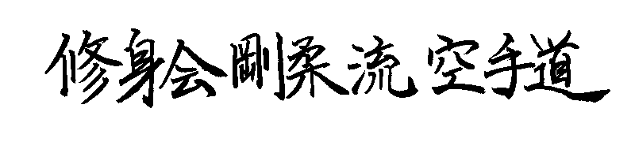

JANUARY, 2016 No. 27

kiai !!!!

2015 BREAKUP & GRADING RESULTS
A successful Breakup night was held at the Hillside dojo on 17P^{thP} December. Grading results………

Promoted to 2nd Kyu Brown Belt
Sophie Karavaras (Westmeadows)

Promoted to 3rd kyu Kyu Brown Belt
Joe MacDonald (Hillside)

Promoted to 5th Kyu Blue Belt
Alex Hodge (Hillside)

Promoted to 6th Kyu Orange Belt
Prashant Sehgal (Westmeadows)
Shane Huntington (Hillside)

Promoted to 8th Kyu
Darren Alejandrino (Hillside)
Kabir Chaudhry (Hillside)

New belts and Certificates will be awarded on the first night back in class.

XMAS BBQ
On 13th December the club held its Annual Xmas function on the banks of the Maribynong River at Maribynong. This was a huge departure from previous years when we held a Xmas Dinner at the Moonee Valley Racing Club. The afternoon took the form of a family BBQ and then those with excess energy played a game of friendly cricket. We had an all-time record… around 55 people attended Here is Dr Shane Huntington from the Hillside dojo showing off his bowling technique…..
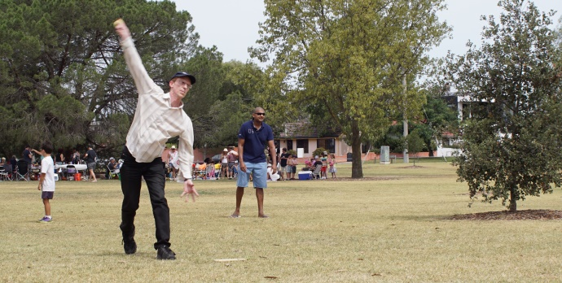

STUDENT OF THE YEAR
The prestigious “Student of the Year” award for 2015 was awarded to Laura Soteriou from the Hillside dojo at our last night of training for 2015.
Throughout the year Laura achieved her Black belt, was regular and supportive in class, and impressed with her maturity and growth in karate. Laura received a Certificate and a watch in recognition of her achievement. Well done Laura!!.
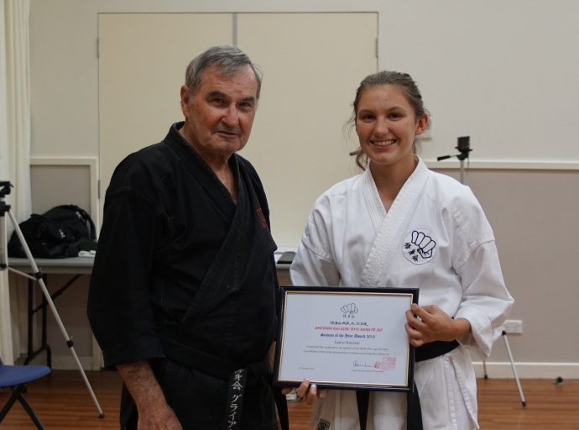
Laura with her “Student of 2015 Award” Certificate, with Shihan Graeme.

ANNUAL TRAINING DAY 2015
On Saturday, 10th October we held our eleventh Annual Training Day and Competition at the Westmeadows dojo. (Bundeena seems a long time ago now !!). Thank you all for attending and helping to make the day enjoyable and productive!!
Before each session during the day Jacob, Jerome and Laura took the class for warmups and stretching. This was part of their Black Belt grading assessment.
In the first two morning sessions Lincoln Sensei taught Tensho kata and applications. Tensho has undergone some substantial technical changes for us since we became a part of the Shigaku Kan dojo in Tokyo, so this was time well spent in consolidating our learnings and making sure we were all on the right path.
This was followed by the Black Belt kata grading test for Jacob, Jerome and Laura. Firstly their assignments “What karate means to me” were read out to the class. These essays were very thoughtfully written and showed a great deal of mature thinking by these young people. The assignments are now loaded on our website. After this, they each were called upon to demonstrate a number of katas to the whole class in a very formal environment. They all did well except Jerome suffered a lapse which saw him doing more katas into the afternoon sessions. He was able to re-group and did a good job of maintaining his focus!!!
After lunch Lincoln Sensei continued the exploration of Tensho kata before handing over to Shihan Graeme who took the class for a session on Maai (Distancing). The next session was also taken by Shihan Graeme in which we explored the meaning and technical aspects of the kiai in karate.
In the afternoon we also held our Annual in-club sparring competition for adults and juniors. There was very spirited sparring, particularly the juniors!!!. This year, for the first time juniors and seniors competed together with strict safety protocols in place.
Thank you to everybody who came along to support the event, and particularly to Suraj who organized life saving food and drinks, and Sensei Lincoln who organized the whole day plus taught and conducted and refereed the sparring competition. Thanks also to Vicki and Sophie who officiated as timekeepers and scorers.
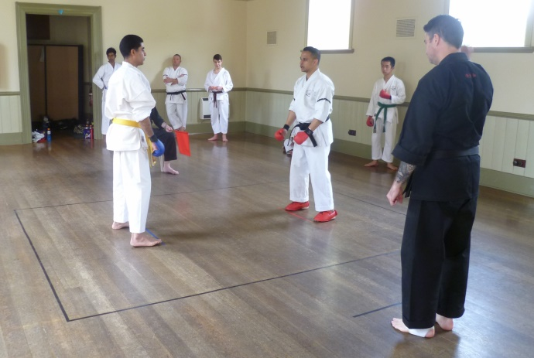
Eventual winner Prashant faces challenger Suraj in the club kumite competition.

NEW DAN GRADES
A major highlight of the day was the promotion of Jacob, Jerome and Laura to 1st Dan Black Belt.
Their promotion was very well deserved, so congratulations.
The club now has 13 Black Belts:- Five 1st dans, three 2nd dans, two 3rd dans, one 4th dan, one 5th Dan and one 6th Dan.
In the evening, after the Training Day, all the Black Belts met for dinner at Chiba Japanese Restaurant in Moonee Ponds..

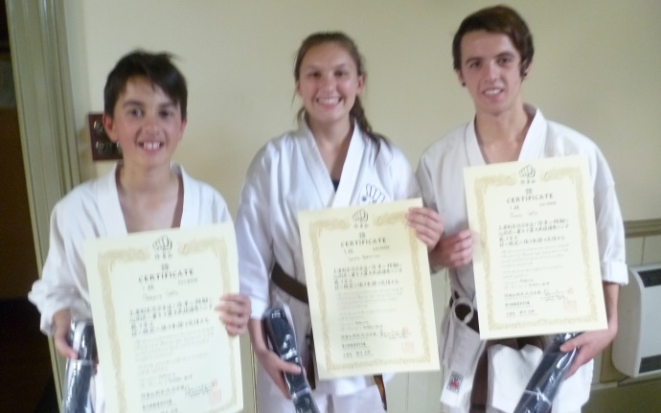
Jerome, Laura and Jacob pictured here with their new certificates..

SHUSHIN KAI CLUB CHAMPION
Our Shushin Kai Kumite Championship was again conducted with great spirit and skills. Prashant Sehgal was the 2015 winner and was presented with a plate engraved with his victory. Well done Prashant !!! The tournament incorporated a “grading” or “handicap” system. Lower grades and females received higher scores for fighting higher grades, thus giving everybody a fair chance of winning. The sparring was based on on close quarter self defence sparring of 30 seconds duration. Prashant went into the tournament as a “new boy” and had no idea how to spar. In the weeks leading up to the tournament special sparring classes were held, and Shihan taught Prashant a simple technique which he was told to use NO MATTER WHAT…… Well Prashant did just that and surprised everybody, including himself, by winning the tournament!!! We now officially call him “Champ” !!! This year under strict control rules, the juniors competed for their own winner This year’s winner was Joe MacDonald.
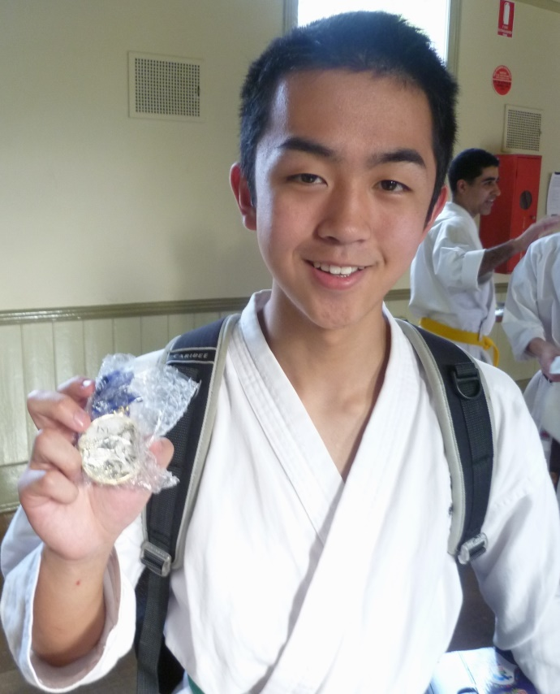
Joichiro MacDonald with his 1st place winner’s medal.

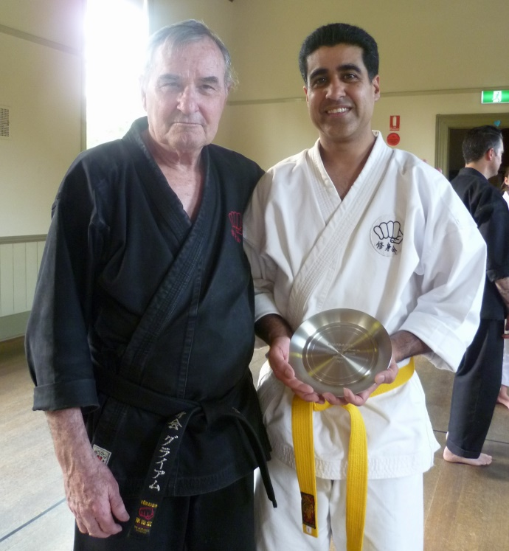
Tournament winner Prashant Sehgal with his winner’s trophy.

SAYONARA BIANCA
Seems we are always saying sayonara to somebody! Last year Bianca from our Westmeadows dojo left us to become a school teacher in South Korea. Fortunately for us Bianca has only gone for one year, and so we are all looking forward to welcoming Bianca home in the second half of 2016.
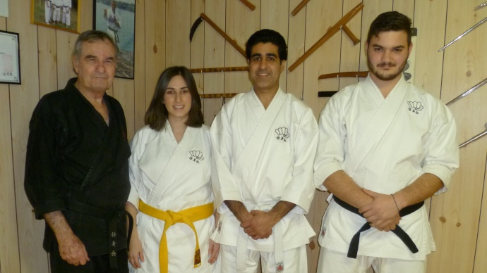
This pic was taken on Bianca’s last night at the hombu dojo before she headed off to South Korea. Pictured here with Shihan Graeme, Prashant (Champ) and Marc (Nidan).

NICOLE KEEPS CONTACT
As you may know, Nicole (2nd Dan) from our Hillside dojo left us last year to relocate to the Gold Coast as she undertakes her university course to become a doctor. Nicole comes and trains with us several times a year when she comes home on university breaks. We all appreciate Nicole maintaining her karate with us!!!!

WEBSITE
Our website www.goju.com.au continues to attract visitors and provides an email facility for interested people to contact us with a view to joining. If you have not visited the website, please do so as it is full of good information!!!

FACEBOOK
Our Facebook is ShushinKaiGojuRyuKarate, or there is a live link from the bottom of the Home Page on our website www.goju.com.au
Please visit our Facebook page regularly as it carries more up to date, day to day information than the website. Please “like” us, share pages and invite your friends to visit and “like” us. Please feel free to make entries and comments.

FUNDRAISING
To meet the costs of running the club members have been busy fundraising. This year we held two chocolate drives. Thank you to everybody who supported us. We are a very small club and have some major fixed costs (particularly insurance and advertising) that we cannot cover with fees alone. A huge thanks also to Suraj who administers the choco drives.

VISIT TO AUSTRALIA BY SENSEI TSUBAMOTO
This year without a doubt, the most important thing to happen to us was the much anticipated visit to Australia by our teacher Tsubamoto Sensei from Tokyo. Every Shushin Kai member was able to train free of charge with Tsubamoto Sensei, one of the late Ichikawa Sensei’s most senior students, and the inheritor of Ichikawa sensei’s Koshudo.
Tsubamoto Sensei (10th Dan) was accompanied to Australia with five of his senior students:- Ishii sensei (8th Dan), I’Hara san (7th Dan), Ishii Kenzo san (6th Dan), Maedomari san (5th Dan), and Tsubamoto Yuki san (5th Dan),
Our first training session was a combined class at the Hillside dojo. It was a full house!!! Everybody greatly enjoyed training with Sensei. During the class we all broke up into kata groups and received training from the Japanese Instructors. But Sensei had the best time, taking the Juniors and lower grades for their own class.
There was a private class for the two Melbourne sensei’s which was followed by another open class at the hombu dojo.

On the Saturday we had a full day of training for everybody at the Westmeadows dojo where once again Sensei and his seniors took the Shushinkai members for detailed instruction. It was a day full of really good memories. Top karate training with a Master of Tsubamoto Sensei’s background and knowledge was a real joy for everyone.
We had a dojo dinner for our Japanese guests at a city hotel and that too was very memorable, filled with great spirit and comradery.
The group did some tourist things too, fitting in a full day tour of the Great Ocean Road and visit to local Melbourne attractions and beaches.
On the Sunday we took the group to an animal sanctuary in Kilmore to meet Australian animals. Many thanks to Vicki for organising the day for us!!!
It was a wonderful experience for us to have Sensei and his group in Melbourne.
We wish to thank Sensei for coming to Australia with his seniors and for sharing his karate with us over the course of the week. Many new friendships were made!!! We plan to visit Tokyo this year and hopefully will welcome our teachers back here in Australia again in the near future!!!
Here are some pics of Sensei’s visit!!
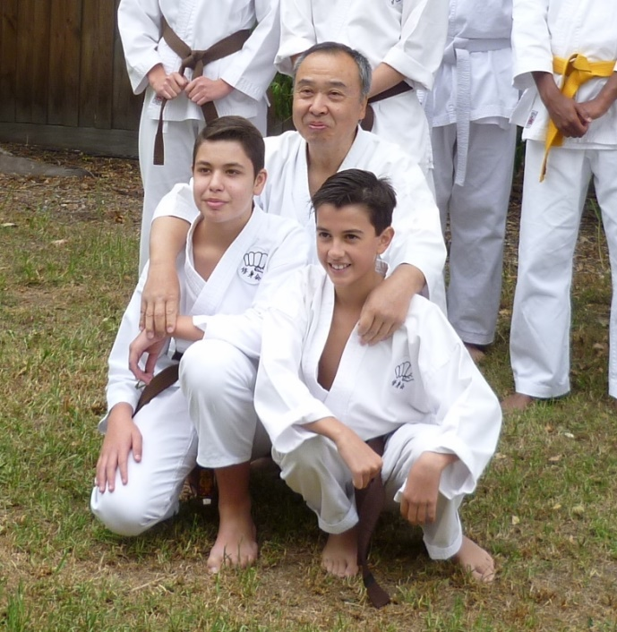
Here is Tsubamoto Sensei with Erjan and Jerome.

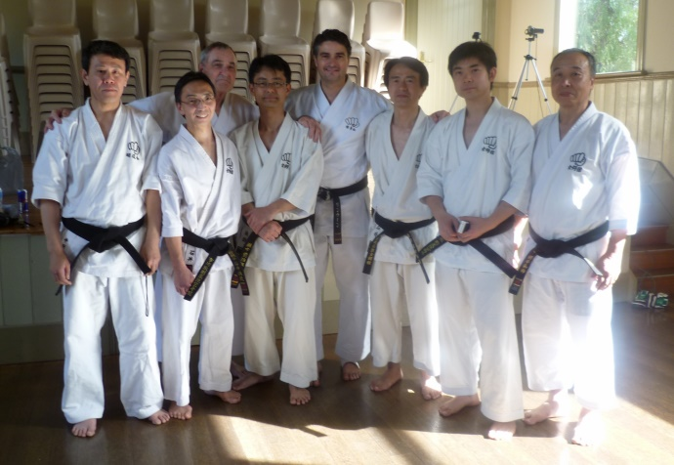
Above: Teachers from Japan and Australia.
Below:- Sensei’s Ishii and I;Hara demonstrate some self defence techniques.
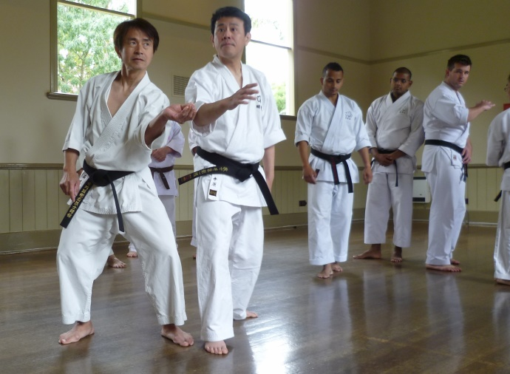
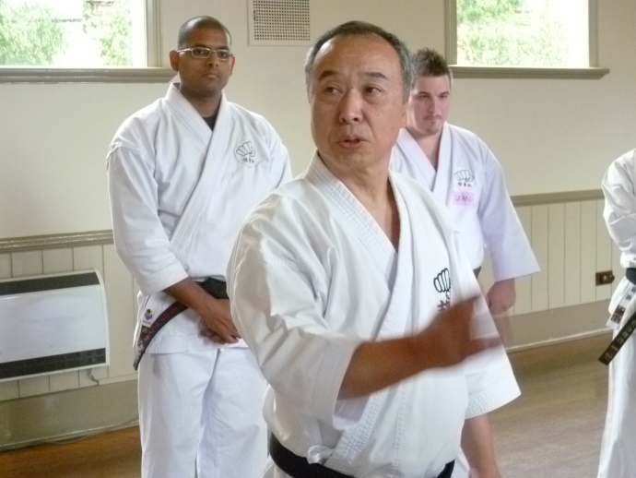
Sensei teaching at the Westmeadows dojo
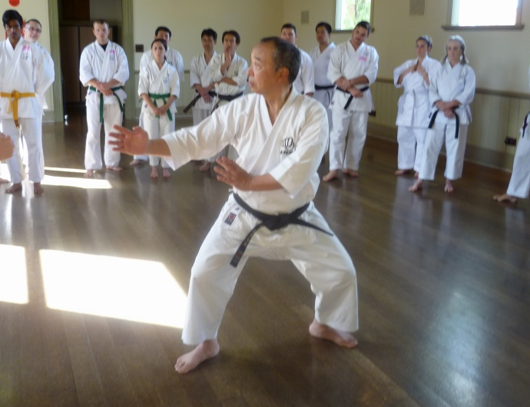
Sensei Tsubamoto teaching at Westmeadows.

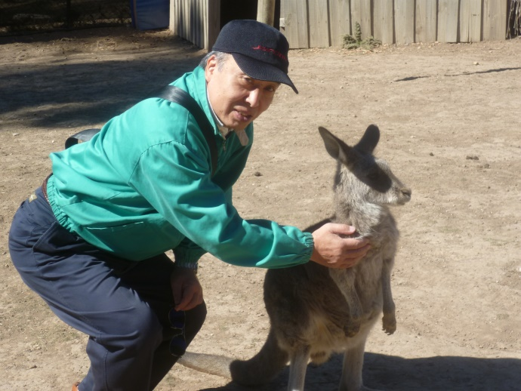
Sensei makes another Australian friend!!

NEW MEMBERS
During the year we had a number of potential member phone calls and internet enquiries. Some came to class, tried out and never came back, some stayed a while and disappeared. Some stayed!!! Some of our longer serving members finished their journey with us. We are looking forward to welcoming some more potential new members who have indicated their interest in joining us this year.

A couple of articles…….
These articles are reprinted from last years’newsletter. Worth reading again, and for new members, just a good read!!

WHAT IS KOSHUDO ??
Many years ago I was told about the existence of Koshudo, the martial art of the late Ichikawa, Sosui sensei. It was described as some bastardised form of cross training put on top of the Goju Ryu. I have come to learn this is completely wrong. So what is it? Five years ago I asked Tsubamoto Sensei where does Goju Ryu stop and Koshudo start. His answer was “Koshudo lives between the wazas”. But whilst that is true, it is not just physical karate, it is psychological and metaphysical as well. One cannot simply insert another technique between other techniques and produce koshudo. Koshudo is the result of Ichikawa Sensei researching and extending his karate beyond the existing Goju Ryu, and in so doing, he created an esoteric new, higher layer to karate. Tsubamoto sensei told me that Ichikawa Sensei taught some Koshudo in his regular classes but it was too advanced, and his students could not understand it or perform it, even though they were teachers with their own dojos. In the last 5 years of his life Ichikawa Sensei transmitted his teachings about koshudo to one person whom he appointed his successor and inheritor of the Koshudo. That person was our teacher, Tsubamoto sensei, who trained diligently to receive Ichikawa’s teachings.
It now follows that although there are other karate schools in Australia claiming lineage to Ichikawa Sensei, our school is the ONLY school teaching Ichikawa Sensei’s karate which is up to date and the ONLY school with access to Ichikawa Sensei’s Koshudo teachings. I might add that those schools claiming lineage to Ichikawa-ha karate in Australia have actually had their lineage broken and have not been associated with Ichikawa karate for many, many years.
Two years ago Tsubamoto Sensei presented me with a copy of Ichikawa Sensei’s Koshudo.
Those teachings are now being passed to senior Shushin Kai students.
By Graeme, Shihan

FROM TSUBAMOTO SENSEI

KARATE UNIFORM OF SOSUIKAN ABOUT THE ORIGIN OF THE BLACK KARATE UNIFORM

Interesting story of Sosuikan’s black karate uniform………..53 years ago (1961), Okinawa Buto (Okinawa traditional dance) was performed as Okinawa Buto Opera at Kabukiza (Kabuki theater) in Tokyo.
Master Ichikawa was invited to perform karate for this event. He accepted this invitation because this offer was from his friend in Okinawa. Sensei Sudo, Sensei Otsuka and several other students joined and performed karate with him.
When they performed karate, their thick and heavy face make up stuck on their karate uniforms and didn’t go away even after washing. Sensei Sudo, Sensei Otsuka and others were university students at that time and couldn’t afford new karate uniforms.
They asked Master Ichikawa to dye their karate uniforms to dark blue. He accepted and Sosuikan’s dark blue karate uniform was started.
At that time, Master Ichikawa was wearing karate uniform all day and his karate uniform’s sleeves were torn out. His thoughtful wife used some samples of
black belt materials from his favourite ” Kanaya karate uniform store” and repaired his karate uniform’s sleeves.
One day, a martial artist came from Okinawa to join the karate training at Ichikawa dojo. After he saw Master Ichikawa was wearing the black sleeves karate uniform, he went back to Okinawa and told his friends ” Mr. Ichikawa in Tokyo is very cheeky guy “.
Later on, Master Ichikawa heard this story from his master Izumikawa. Master Ichikawa was very seriously thinking about this issue.
He decided to dye the entire karate uniform black.
Master Ichikawa made a rule that whoever is above the instructor level at Sosuikan is to wear black karate uniform. Only the top of the Karate uniform was black at this time.
Later on, he changed this rule to black top & white bottom karate uniform for the instructors and black top & bottom karate uniform for masters. And again, he
changed this rule to black top & white bottom karate uniform for below 2nd dan instructors and black top & bottom karate uniform for above 3rd dan instructors.
(spring in 1962)
His students supported this black karate uniform very strongly. Because Sosuikan karate training were at the park on Monday, Wednesday, Friday and Sunday (morning, day & night) and the black karate uniform was good for dirt, mud, blood, etc.. It was also easy for the new students to find the instructors.
But most of all, students dream to wear the black karate uniform and train hard to wear this one day.
Not many people know this but after Master Hatsumi who is teaching Ninja skills saw this black karate uniform, he loved it and adopted it for his Ninja training.
This is how black Ninja training uniform was started. (Ninja wears black for long time but not Ninja training uniform).
So the black karate uniform started by Master Ichikawa’s idea. Many martial artists are wearing the black Karate uniforms all over the world today but not many people know the history behind this story.

IMPORTANT NEWS : FEES
This year once again (6th year), there will be no increase in training fees.
Following the 2015 AGM our Membership fees have increased by $5 to $80
Given that we are not increasing training fees would all members please pay their fees promptly on the FIRST training night of each month. (Which means of course, bring your fees to the first night back in class).

PAYING FEES
We accept cash or cheque for any fees.
You can also pay your fees via direct banking on the internet.
Ask Shihan for the banking details.

Continued////

2016 CLASSES START DATES

Westmeadows Dojo ( Westmeadows Hall, Raleigh St, Westmeadows) : Monday, 1st February at 7.00 pm

Hillside Dojo (Banchory Community Centre, Banchory Ave, Hillside): Tuesday 2nd February at 7.00pm.

Hombu dojo, Westmeadows : Wednesday, 3rd February, at 7.00 pm

THE YEAR AHEAD IN SHÚSHINKAI
We are looking forward with great anticipation to seeing you all when class recommences. We are sure 2016 will be exciting and productive for everybody!!!
See you back in class………..
Shihan Graeme
Sensei Lincoln
January, 2016

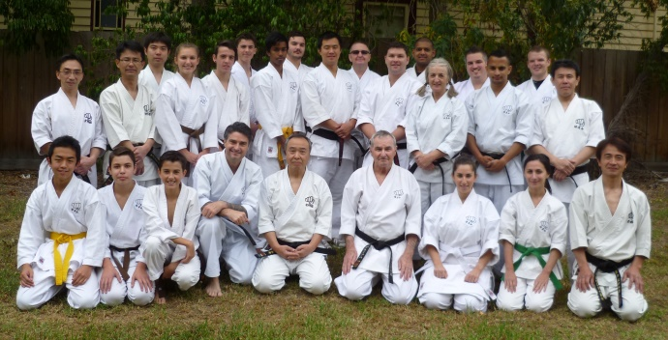

The full group photograph of Shushin Kai and Shigaku Kan members taken at Westmeadows dojo.

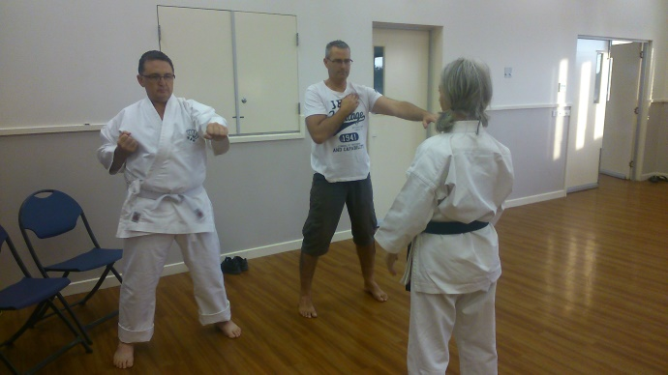

New students at Hillside receiving private lesson from Vicki (4th Dan) Hello…is that Craig?????

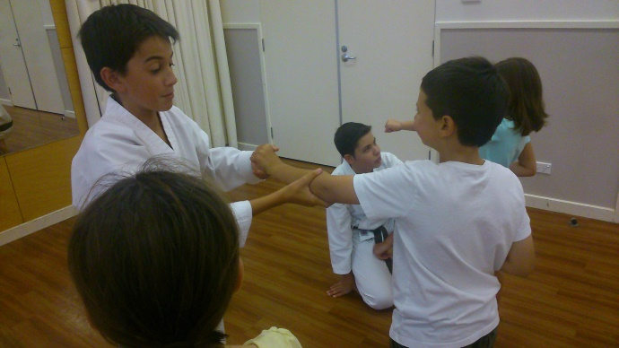

Here is Jerome taking a class of juniors at Hillside.

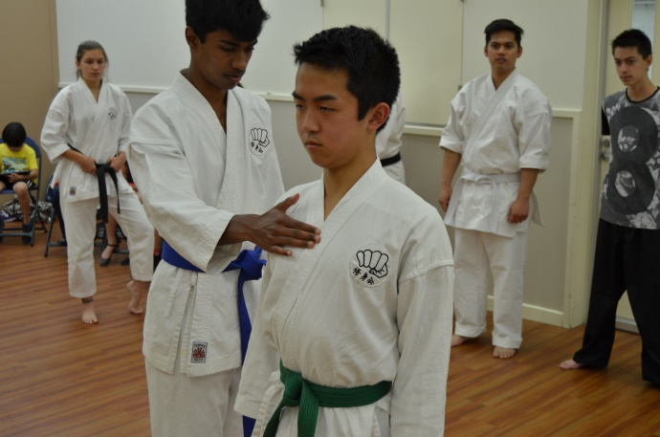
Checking body form at Hillside dojo.

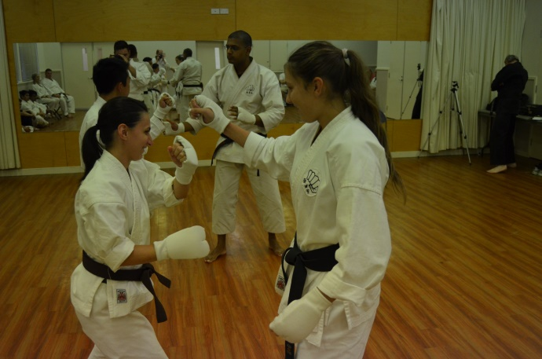

Sophie (Westmeadows) and Laura (Hillside) sparring.

