SHÚSHIN KAI GOJU RYU KARATE
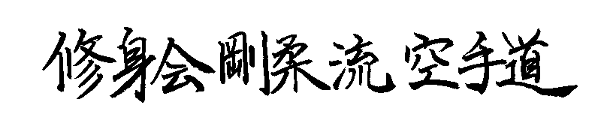

JANUARY, 2015 No. 26

kiai !!!!

2014 BREAKUP & GRADING RESULTS
A successful Breakup night was held at the Hillside dojo on 18P^{thP} December. Grading results………

Promoted to 1st^{nd} Kyu Brown Belt
Jacob Vella

Promoted to 3rd Kyu Brown Belt
Erjan Rustim

Promoted to 5th Kyu Blue Belt
Glenn Sharp (Westmeadows)
Sophie Karavaras (Westmeadows)

Promoted to 6th Kyu Orange Belt
Matthew Hohmann

Promoted to 7th Kyu
Joichiro MacDonald

New belts and Certificates will be awarded on the first night back in class.

XMAS DINNER
On 22nd December the club held its Annual Xmas Dinner at the Legends Bistro at the Moonee Valley Racing Club. Some 32 or so people attended, and all had a great night! Here’s a happy pic of Nicole and Andrew.

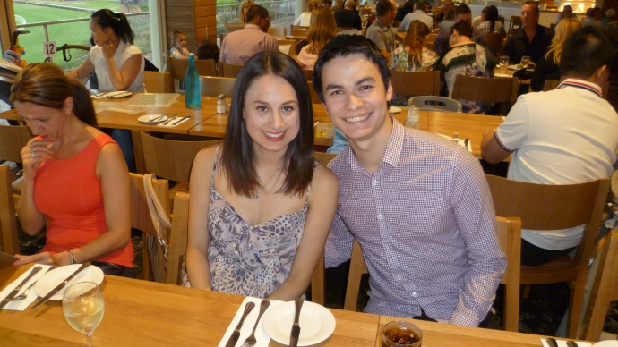

STUDENT OF THE YEAR
The prestigious “Student of the Year” award for 2014 was awarded to Jacob Vella from the Hillside dojo at our last night of training for 2014.
Throughout the year Jacob has been regular to class and has really blossomed as his karate has improved. . He has also helped new students and we are very pleased with his effort all year long!! Hopefully Jacob will receive his coveted Black belt this year!!! Well done Jacob.

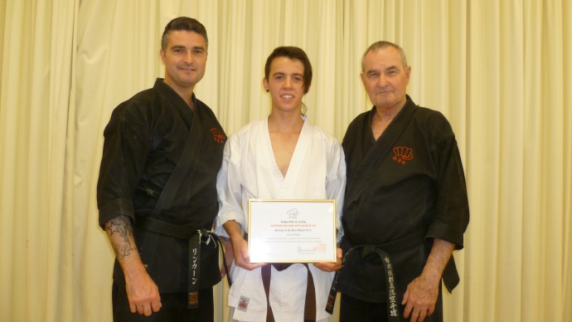
Jacob with his “Student of 2014 Award” Certificate, with Shihan Graeme and Sensei Lincoln ,

WEBSITE
Our website Uwww.goju.com.au was recently updated. Thank you to Suraj Fernando for the technical work. New photos taken in Japan have been added to the photo section, and new video added to the member’s section. In the next month or so we have a project to update the lineage and Black Belt area of the site, with bios, and photos.

FACEBOOK
Our Facebook is SushinKaiGojuRyuKarate, or there is a live link from the bottom of the Home Page on our website www.goju.com.au
Please visit our Facebook page regularly as it carries more up to date, day to day information than the website. Please “like” us, share pages and invite your friends to visit and “like” us. Please feel free to make entries and comments.

ANNUAL TRAINING DAY 2014
On Saturday, 4th October we held our tenth Annual Training Day and Competition. For the first time we held it at the Westmeadows dojo. Thank you all for attending and helping to make the day enjoyable and productive!! In the morning Suraj taught double blocks and Vicki taught bunkai from Kurarunfa kata. This was part of their grading test. Sensei Lincoln then taught intermediate level push hands based on the Yin-Yang symbol, which is ideal for close quarters self defence. This was followed by a grading demonstration for Suraj who was testing for 3rd Dan, Vicki who was testing for 4th Dan, and Lincoln Sensei who was testing for 5th Dan. They each demonstrated two advanced kata. All three did an outstanding job and are a credit to themselves and the club. In the afternoon Sensei Lincoln took the class for an advanced session on Kamae Kumite. Shihan Graeme taught the kata Unshu supported by Asanka, Suraj and Vicki who took small groups for detailed instruction. This was followed by a session on Tai Sabaki applications by Graeme Shihan.
In the afternoon we also held our Annual in-club sparring competition for adults and juniors. There was very spirited sparring, particularly the juniors who were all assigned a senior Black Belt as a coach.
Thank you to everybody who came along to support the event, and particularly to Suraj who organized life saving food and drinks, and Sensei Lincoln who organized the whole day plus taught and conducted and refereed the sparring competition. Thanks also to Vicki and Edwin who officiated as timekeepers and scorers.
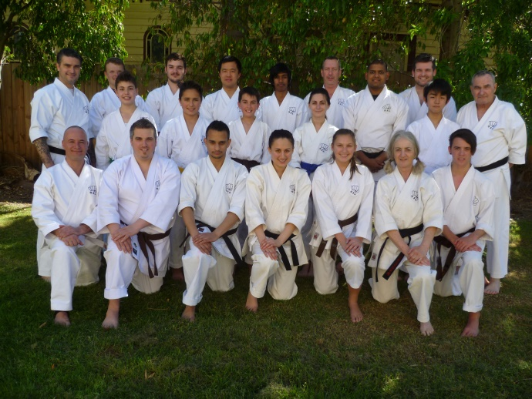
It was a beautiful sunny day, so we all lined up for this class photo at the Training Day.

NEW DAN GRADES
The highlight of the day (apart from the competition mentioned later), was the promotion of Suraj to 3rd Dan, Vicki to 4th Dan, and Lincoln Sensei to 5th Dan Master. Well done to all of you. Their promotion was very well deserved, so congratulations

The club now has 10 Black Belts:- Two 1st dans, three 2nd dans, two 3rd dans, one 4th dan, one 5th Dan and one 6th Dan.

In the evening, after the Training Day, all the Black Belts met for dinner at Chiba Japanese Restaurant. There the three promoted Black Belts were obliged to consume a teaspoon of wasabi as punishment for doing so well!!! Such is our club culture!!
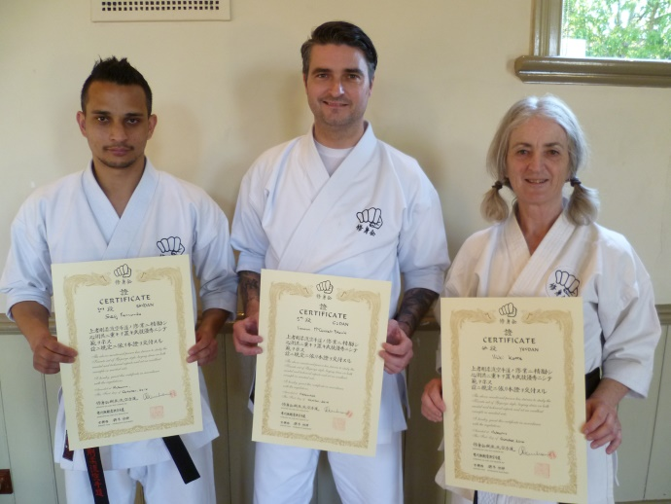
Suraj Fernando, Sandan, Sensei Lincoln Godan, and Vicki Katte, Yondan, pictured here with their new certificates..

SHUSHIN KAI CLUB CHAMPION
Our Shushin Kai Kumite Championship was again conducted with great spirit and skills. Suraj Fernando was the 2014 winner and was presented with a plate engraved with his victory. Well done Suraji!!! The tournament was designed to incorporate a “grading” or “handicap” system so lower grades and females received higher scores for fighting higher grades, thus giving everybody a fair chance of winning. Also, the sparring was not based on AKF rules, but on close quarter sparring of 30 seconds duration.
As in previous years we conducted a junior version of the tournament. This year’s winner was Jacob Vella.
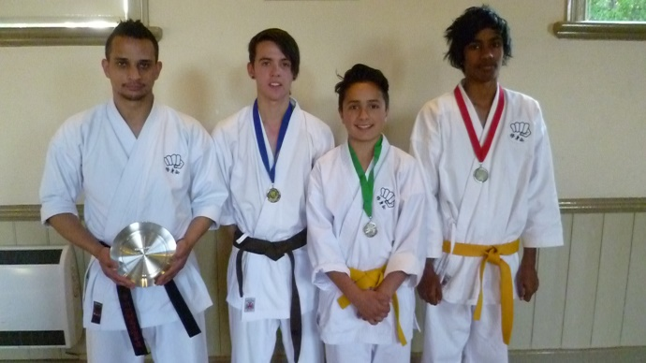
Tournament winners! Suraj Fernando (Club Kumite Champion), with Junior placegetters…..JacobVella 1st Place, Matty Hohmann 3rd Place, Devin Cooray 2nd Place.

VISIT TO JAPAN
In October, Shihan Graeme and Sensei Lincoln travelled to Japan to train with our teacher, Tsubamoto Sensei at the Shigaku kan dojo in Tokyo. It was Shihan Graeme’s sixth visit and Sensei Lincoln’s first.
The training was very hard, and Sensei arranged extra lessons for us. Nevertheless, we took the opportunity to visit Mt Fuji, and spent a full day touring Tokyo to see shrines, temples and places of interest. We also did some good shopping, particularly in Ginza where we kept Tiffany’s, Mitsukoshi department store and UniQlo in business. We also hit Omotesando and shopped in the Oriental Bazaar and Michael Kors. We also ate at the Magnolia Bakery for memories of New York!!

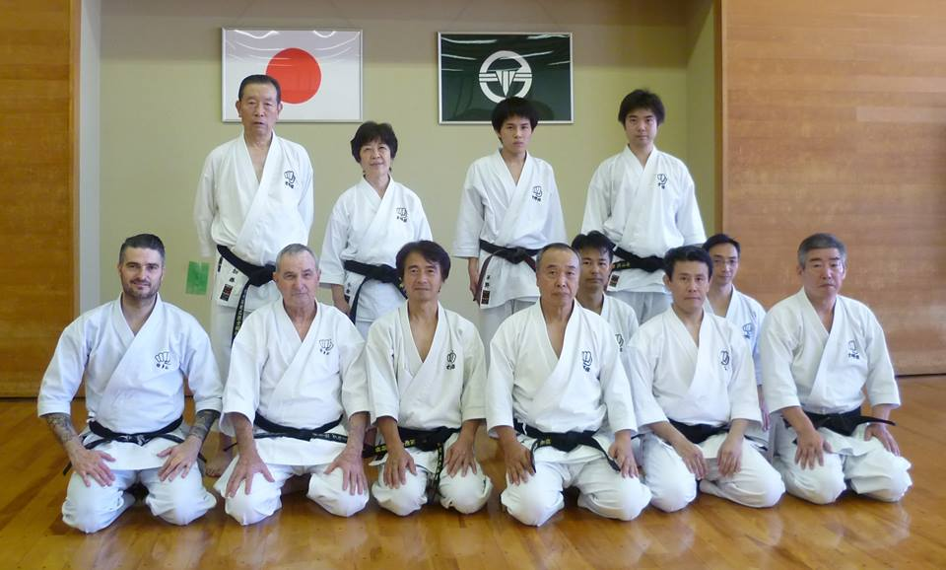
This pic shows the Aussie sensei’s with Shigaku Kan on the last day of our training,

However we certainly trained. We trained longer, harder and more times than any previous visit. After each session we dragged our bodies out of the dojo, spent a couple of hours trying to recover, then went back for more. Sensei wanted to get a lot of training into the two sensei’s, particularly Sensei Lincoln, who Tsubamoto Sensei appointed the successor to Ichikawa Goju Ryu and Koshudo in Australia. The karate we are learning now is very difficult to understand and even harder to get right consistently, if at all. As in previous years we concentrated on preparatory exercises, and heaps and heaps of basics.
Lincoln Sensei received hours of extra training on the kata Saifa from Ishii sensei, under the watchful gaze of Tsubamoto Sensei. This was to train Lincoln Sensei in the highest level version of this kata as taught by Ichikawa Sensei, to teach karate body form. Sensei Tsubamoto also taught us Koshudo techniques that made our eyes water!!!! We were even taught koshudo techniques sitting down in restaurants!!! One whole session was spent doing throws (ukemi waza) on the concrete floor. We were trained in throws and takedowns from Tensho (yes….Tensho) and Kurarunfa. That was a blast!!!
One of the highlights for us was Shihan Graeme being presented with a copy of the Koshudo written by Ichikawa Sensei. The other was sitting down on the dojo floor with Sensei as he showed us the Bubishi with Ichikawa Sensei’s handprint, and told us many stories about the Bubishi and how it is passed down from Master to student. Sensei told us how Ichikawa sensei passed down the Bubishi, and how Bubishi CORRECTLY handed down was evidence of lineage not some prize……
Training also included detailed instruction in Gekiha, the three Naihanchin kata, Saifa, Sanchin and Kurarunfa, as well as bunkai. But the best part?? I think it was learning Koshudo. If your sensei’s ever get the hang of it we might introduce some of it in our classes!
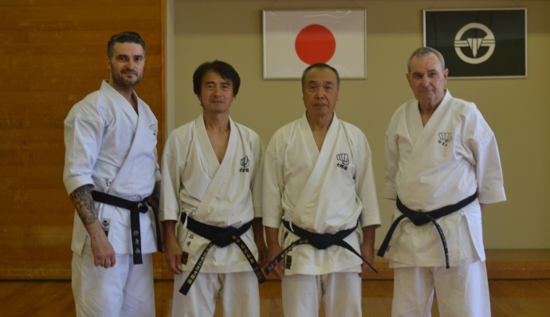
After the last training session in Tokyo, Sensei’s Lincoln, Ishii, Tsubamoto and Graeme

DOJO DINNER
On our last night Shigaku Kan and Shushin Kai combined for a Farewell Dojo Dinner Party. Lots of food, lots of drink (especially white sake) speeches and lots of laughter!!!!!!

SAYONARA NICOLE
Nicole Georgiadis joined Shushin Kai on 16th February 2006, at our Hillside dojo, aged 13 years. Nicole achieved Shodan (1st dan) on 29 November 2009. She was graded Nidan (2nd Dan), October 5th, 2013. In 2013 Nicole won our kumite tournament to become the Club Champion. From a shy young girl, Nicole became one of Shushin Kai’s most dedicated students, and took a leadership position in the club teaching at the Hillside dojo. Life has twists and turns, resulting in Nicole leaving us in 2015 to live in Queensland where she will be attending University to follow her dream of becoming a doctor. We will all miss Nicole and wish her every success in her new adventures. Most of all we thank her for the support she has given the club over many years and the the contribution she has made to the development of members as a teacher and role model.
At our recent Christmas Dinner the club presented Nicole with a parting gift, a diamond studded engraved watch . All Shushin Kai members donated money to purchase this gift. We look forward to hearing from Nicole regularly thanks to modern communications, and to welcoming her back to the club sometime in the future.

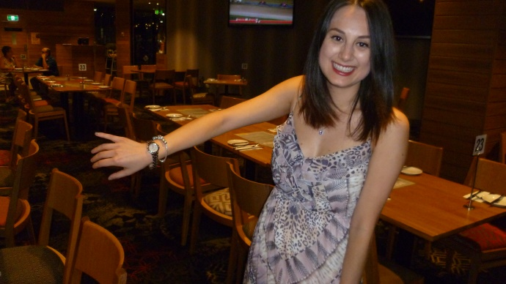
Nicole shows off her new watch from all members of Shushin Kai

FUNDRAISING
To meet the costs of running the club and to support the upcoming visit to Australia by Shigakukan teachers, members of our club have been busy fundraising. Our major effort this past year was a chocolate drive. Thank you to everybody who supported us. We still have more chocolates to sell and more money to come in, so let’s go folks!!!!
We are a very small club and have some major fixed costs (particularly insurance and advertising) that we cannot cover with fees alone.

VISIT TO AUSTRALIA BY SENSEI TSUBAMOTO
Sensei Tsubamoto has indicated his intention to visit us in Australia this year along with some of his senior students, including Nanadans (7th Dans), I’hara, Ishii, and Yuki Tsubamoto (Godan, 5th Dan).
When Sensei’s plans firm up and we have dates, we will let you know! Sensei’s visit here will be a really big milestone in the history of Shushin Kai as we will all have the opportunity to train with Tsubamoto Sensei, one of Ichikawa Sensei’s most senior students, and the inheritor of Ichikawa sensei’s Koshudo.

NEW MEMBERS
During the year we had a number of potential member phone calls and internet enquiries. Some came to class, tried out and never came back, some stayed a while and disappeared. Some stayed!!! Some of our longer serving members finished their journey with us. We are looking forward to welcoming some more potential new members who have indicated their interest in joining us this year.

BACK TO WESTMEADOWS
In 2014 the club left the Ginifer (Gladstone Park) dojo where we had trained for many years and returned to the Westmeadows dojo. This was caused by us being quite badly treated by a local cricket club which took over the Ginifer premises and basically made us most unwelcome as they pursued their own agenda. So we returned to the Westmeadows dojo (which has a wooden floor and which is clean, unlike the Ginifer mess). We changed the Westmeadows times so that the club meets at the Westmeadows Hall in Raleigh St, Westmeadows on Mondays, and at the Hombu dojo at Shihan’s dojo in Westmeadows on Wednesdays.

WHAT IS KOSHUDO ??
Many years ago I was told about the existence of Koshudo, the martial art of the late Ichikawa, Sosui sensei. It was described as some bastardised form of cross training put on top of the Goju Ryu. I have come to learn this is completely wrong. So what is it? Five years ago I asked Tsubamoto Sensei where does Goju Ryu stop and Koshudo start. His answer was “Koshudo lives between the wazas”. But whilst that is true, it is not just physical karate, it is psychological and metaphysical as well. One cannot simply insert another technique between other techniques and produce koshudo. Koshudo is the result of Ichikawa Sensei researching and extending his karate beyond the existing Goju Ryu, and in so doing, he created an esoteric new, higher layer to karate. Tsubamoto sensei told me that Ichikawa Sensei taught some Koshudo in his regular classes but it was too advanced, and his students could not understand it or perform it, even though they were teachers with their own dojos. In the last 5 years of his life Ichikawa Sensei transmitted his teachings about koshudo to one person whom he appointed his successor and inheritor of the Koshudo. That person was our teacher, Tsubamoto sensei, who trained diligently to receive Ichikawa’s teachings. Those teachings are now being passed to senior Shushin Kai students.

FROM TSUBAMOTO SENSEI

KARATE UNIFORM OF SOSUIKAN ABOUT THE ORIGIN OF THE BLACK KARATE UNIFORM
Interesting story of Sosuikan’s black karate uniform………..53 years ago (1961), Okinawa Buto (Okinawa traditional dance) was performed as Okinawa Buto Opera at Kabukiza (Kabuki theater) in Tokyo.
Master Ichikawa was invited to perform karate for this event. He accepted this invitation because this offer was from his friend in Okinawa. Sensei Sudo, Sensei Otsuka and several other students joined and performed karate with him.
When they performed karate, their thick and heavy face make up stuck on their karate uniforms and didn’t go away even after washing. Sensei Sudo, Sensei Otsuka and others were university students at that time and couldn’t afford new karate uniforms.
They asked Master Ichikawa to dye their karate uniforms to dark blue. He accepted and Sosuikan’s dark blue karate uniform was started.
At that time, Master Ichikawa was wearing karate uniform all day and his karate uniform’s sleeves were torn out. His thoughtful wife used some samples of
black belt materials from his favourite ” Kanaya karate uniform store” and repaired his karate uniform’s sleeves.
One day, a martial artist came from Okinawa to join the karate training at Ichikawa dojo. After he saw Master Ichikawa was wearing the black sleeves karate uniform, he went back to Okinawa and told his friends ” Mr. Ichikawa in Tokyo is very cheeky guy “.
Later on, Master Ichikawa heard this story from his master Izumikawa. Master Ichikawa was very seriously thinking about this issue.
He decided to dye the entire karate uniform black.
Master Ichikawa made a rule that whoever is above the instructor level at Sosuikan is to wear black karate uniform. Only the top of the Karate uniform was black at this time.
Later on, he changed this rule to black top & white bottom karate uniform for the instructors and black top & bottom karate uniform for masters. And again, he
changed this rule to black top & white bottom karate uniform for below 2nd dan instructors and black top & bottom karate uniform for above 3rd dan instructors.
(spring in 1962)
His students supported this black karate uniform very strongly. Because Sosuikan karate training were at the park on Monday, Wednesday, Friday and Sunday (morning, day & night) and the black karate uniform was good for dirt, mud, blood, etc.. It was also easy for the new students to find the instructors.
But most of all, students dream to wear the black karate uniform and train hard to wear this one day.
Not many people know this but after Master Hatsumi who is teaching Ninja skills saw this black karate uniform, he loved it and adopted it for his Ninja training.
This is how black Ninja training uniform was started. (Ninja wears black for long time but not Ninja training uniform).
So the black karate uniform started by Master Ichikawa’s idea. Many martial artists are wearing the black Karate uniforms all over the world today but not many people know the history behind this story.

Footnote: Within Shushin Kai, only the two sensei’s are permitted to wear black uniforms.

IMPORTANT NEWS : FEES
This year once again (5th year), there will be no increase in training fees or Membership Fees.,
Given that we are not increasing fees would all members please pay their fees promptly on the FIRST training night of each month. (Which means of course, bring your fees to the first night back in class).

PAYING FEES
We accept cash or cheque for any fees.
You can also pay your fees via direct banking on the internet.
Ask Shihan for the banking details.

2015 CLASSES START DATES

Westmeadows Dojo
Westmeadows Hall, Raleigh St, Westmeadows: Monday, 2nd February at 7.00 pm

Hillside Dojo
Banchory Community Centre, Banchory Ave, Hillside:
Tuesday 3rd February at 7.00pm.

Hombu dojo, Westmeadows
Wednesday, 4th February, at 7.00 pm

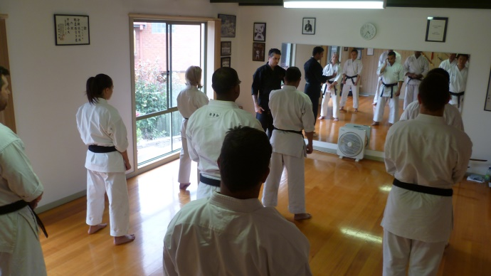

Sensei Lincoln teaching at one of our regular Black Belt classes at the Hombu dojo. Black Belt only classes are held the first Saturday of each month.

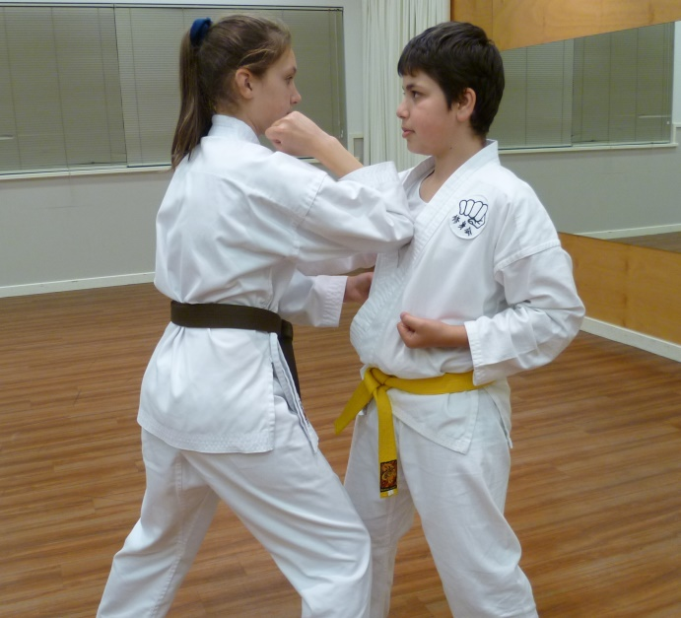
Laura (2nd Kyu, practicing Sanseiru bunkai with Erjan,.

THE YEAR AHEAD IN SHÚSHINKAI
I am looking forward with great anticipation to seeing you all when class recommences. I am sure 2015 will be exciting and productive for everybody!!!
See you back in class………..

Shihan Graeme January, 2015

