JANUARY, 2010 No. 21
SHÚSHIN KAI GOJU RYU KARATE


kiai !!!!

2009 BREAKUP & GRADING RESULTS
A successful Breakup night was held at the Hillside dojo on 17P^{thP} December. A good class was in attendance for a tough workout on basics, bunkai, sparring and kata for the grading. Many thanks to Amie who organized the annual Xmas raffle.
Many, many thanks to those who supported the raffle by donating money and prizes.
And to all members who assisted the club by selling raffle tickets. Thank you all.
Paige McDowell from Hillside won this year's Student of the Year Award, and received a certificate and club polo shirt. Well done Paige!
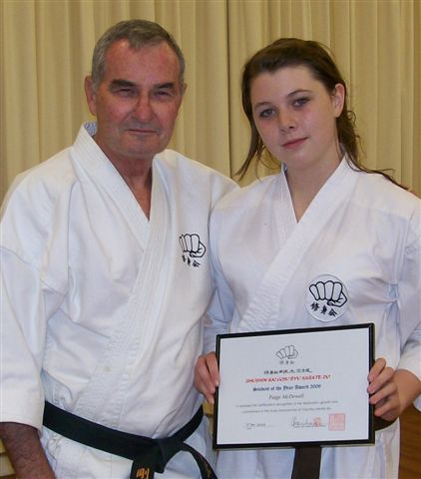
Paige with her Student of the Year Award, with Shihan Graeme
Grading results, in no particular order ...Promoted to....
U8th Kyu
Yanek Bogusz
Viktor Jablonsky
5th Kyu
Kimberley Johnston
Adam Blanche
U3rd Kyu
Daniel Ganeshanantham
Alexander Ignatidis
1st Kyu
Bridgette Gwynne
Paige McDowell
2009 RAFFLE
The 2009 Raffle was drawn at the last night of training at Hillside. The winners were:
5th Prize: A collection of 10 DVD’s
Valued at $50.00 Donated by Shihan Graeme.
5th Prize: went to Yanek Bogusz
4th Prize: A collection of 10 DVD’s.

Valued at $ 50 Donated by Amie Kelly.
4th Prize went to Asanka Silva.
3rd Prize: 2 bottles of Riccadonna and 1 tin of Dansk shortbread cookies and 1 box of Roses chocolates,
Valued at $60.00.
3rd Prize went to ticket sold by Yanek Bogusz.
2nd Prize: The “Troy Aquilina” Food Hamper

Valued at $160.00 Donated by Troy Aquilina
2nd Prize went to Viktor Jablonsky.
1st Prize: “Pamper Me” Hamper
Tons of stuff, valued at $300.
1st Prize went to Adam Blanche.
Many thanks to those who assisted the raffle by selling tickets and a special mention to Amie who once again did a very professional job of organizing the raffle and prizes. Also many thanks to those members who made sizable cash donations to enable us to purchase many of the prizes. Thank you to Troy, Suraj, Bill and Michael.
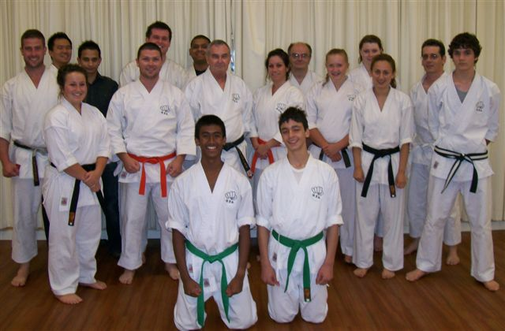
The last class for 2009 at the Hillside dojo.
CAMPS & GRADINGS AT WU LIN
The big event for us was the Black Belt Training Camp and Grading conducted by Kyoshi Sumarac on the weekend of 29/30 November, 2009. We had only a small group attend this year. The highlight was the Grading Demonstration in which Nicole Georgiadis was promoted to Shodan.
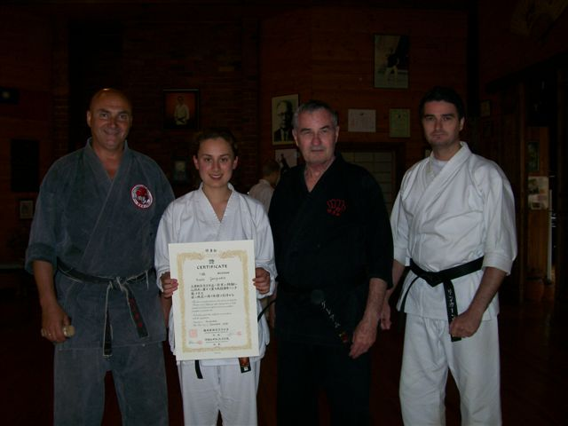
Nicole with her Shodan Certificate, with Kyoshi James, Shihan Graeme and Sensei Lincoln.
XMAS DINNER
On December 21st the club held its Annual Xmas Dinner at the Legends Bistro (named after Sensei Lincoln) at the Monee Valley Racing Club. Some 22 people attended, and all had a great night!
WEBSITE
Our website Uwww.goju.com.auUT is still attracting a good number of visits since it was introduced in January 1999. At this time of writing, the site has received 47,457 visits, meaning 4,353 visits were for 2009. Many thanks to Suraj and Bill who look after the technical side of the site. The photo section has been recently updated, with photos from Wu Lin, the Training Day, Black Belt Camp, the Breakup Night at Hillside, and Shihan’s visit to Japan. The website is currently undergoing a major update, and we will let you know when this is completed.
NEW STRATEGIES
In December 2007, a group of senior members met at Sensei’s house to discuss strategies and plans for guiding the club into the years ahead, to help attract new members, and how to retain members. As a result of this meeting we now have a PowerPoint Presentation which we send to people enquiring about joining our club. The short presentation introduces our club, answers the usual questions and details training times/venues and costs. It has been very well received by people seeking information and has led to a number of new members. We also produced a short DVD which includes interviews with a number of our members and footage of classes in action at Hillside. The DVD is for walk-in visitors, giving them something to take away. When our website update is completed the Powerpoint Presentation will be accessed via the internet directly. People enquiring about lessons will be sent a URL which will take them directly to the Presentation. This way we have been able to improve the presentation with more photos to make it more interesting. Such a large file is too difficult to send by email as in the past. Later we will add the DVD to the website as well. The only way to access these items will be by direct URL entry. There will be no access from the Home Page.
ANNUAL TRAINING DAY
On Saturday, 3rd October we held our fifth Annual Training Day and Competition at Ginifer dojo. Thank you all for attending and helping to make the day enjoyable and productive!! Sensei Lincoln taught a series of empi waza, and Shihan Graeme conducted a theoretical and practical session on Kamae.
Our Black Belt Grading was great too, with Nicole Georgiadis achieving her Black Belt in our dojo grading. She went on to attend the Black Belt camp in November and demonstrated her skills to Kyoshi, after which she received her new belt and certificate.
Our Shushin Kai Kumite Championships were conducted with Great Spirit and skills. Adam Blanche from The Tullamarine dojo was the winner and was presented with a plate engraved with his victory! Well done Adam!!! The tournament was designed to incorporate a “grading” or “handicap” system so lower grades and females received higher scores for fighting higher grades, thus giving everybody a fair chance of winning. Also, the sparring was not along based on AKF rules, but on close quarter sparring of 30 seconds duration.
I would like to thank Suraj for arranging lunch/drinks etc. Also Bill and Edwin for administering the kumite, and Sensei Lincoln who not only refereed for 2 hours and taught several sessions, but who planned and organised the whole event. Thanks to you all!
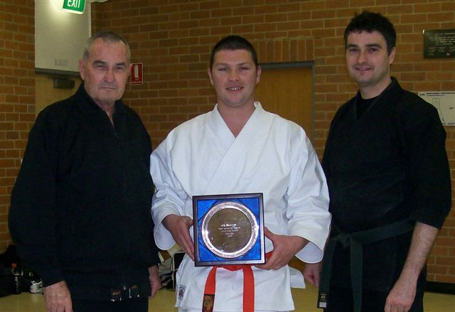
Adam receiving the Campionship Trophy with Shihan Graeme and Sensei Lincoln.
PROGRESS IN 2009
During 2008 we saw the usual comings and goings with some people trying karate for a short time before disappearing. Unfortunately we lost three Shodans. Vanessa moved to Sydney to live, whilst two male Shodan teenagers lost the “passion”, or found continued karate practice didn’t fit in with their lifestyle. It’s disappointing that people put in such a great effort to achieve their Black Belts and then stop training. There are two reasons why this is a disappointment…. Firstly, karate training STARTS in earnest when you achieve your black belt. Gaining shodan means you have put in the preparatory work needed before being exposed to the real meaning of karatedo through higher level training. Secondly, it means that the new shodan has not “put back in” to the development of the club or others through assuming higher responsibilities within the club such as teaching, coaching and helping others. This is also a very important lesson in martial arts.
We wish to thank our new members for choosing our club, and hope that you enjoy your karate journey.
We would like to welcome Yanek Bogusz and Viktor Jablonsky who joined us during 2009, and who have stayed. A number of others started but gave up for various reasons along with several who had been with us for a while...
The club now has 11 Black Belts:- five 1st Dans, two 2nd dans, two 3rd dans, one 4th dan and one 5th dan.
IMPORTANT NEWS : FEES
This year there will be again NO increase in the clubs fees.
This is about the fourth year in a row we have resisted putting fees up.
Fees are:-
Annual Membership Fee $75
UMonthly Training Fees
Senior (12 yrs & over & Juniors 2 hrs per night) $65
Casual fee for this group $15 per session
Juniors (11 yrs & under, 1 hr per night) $50
Casual fees for this group $10 per session.
Special discounts
If members pay fees 3 or more months in advance we will apply a 10% Discount. This means the senior fee is $175.50, for 3 months, which is $4.50 cheaper than the current rate. The Junior rate is $135.
Would all members please pay their fees promptly on the FIRST training night of each month. (Which means of course, bring your fees to the first night back in class).
PAYING FEES
We accept cash or cheque for any fees. This year we also introduced the ability to pay your fees via direct banking on the internet.
We bank with Members and Education Credit Union
BSB 803-140
Name of Account: Japanese Karate Academy Inc.
Account Number: 14069239
When making payments please add a description (ie Membership Fees), and send Shihan a short email (sensei@primus.com.au ) saying you have made the payment.
POLO SHIRTS
Any club members wishing to obtain the club’s white polo shirt embroidered with the club’s name should see me to arrange obtaining one. This shirt is worn by club members when attending official club events, tournaments and so on. Price:- $35.
BLACK TRAINING TOPS
Embroidered with the Shúshin Kai name front and back, made from non-pilling polar fleece. Please see me to arrange your top if you would like one. Price is $55, adult sizes only. These tops are designed to be worn over your uniform and are great for wearing on those cold nights. They are the only additional clothing permitted to be worn in class.
2010 CLASSES START DATES
Westmeadows Dojo (Raleigh St Westmeadows): Monday, 1st February at 7.15 pm
Hillside Dojo (Banchory Ave, Hillside): Tuesday 2nd February at 7.00pm.
Ginifer dojo (Carrick Drive, Gladstone Park) Wednesday, 3rd February. At 7.00 pm
NEW CLUB BADGES
This year we introduced a new badge for our uniforms. The badge (shown below) shows the Ichikawa Goju fist and our club name. We will also continue to wear the club name on the back of our uniforms. The introduction of this badge is in recognition of our membership of Ichikawa-ha Goju-ryu Karatedo Sosui-kai in Tokyo, Japan through Tsubamoto Sensei (10th Dan Kaicho), Shigaku Kan.
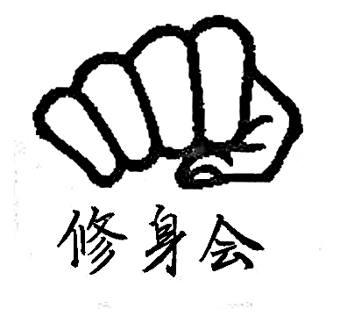
JAPAN
In October, Kyoshi James and Shihan Graeme were invited to visit Japan by Kancho Robert Taiani, 9th Dan Kancho, Jinshinkan (Sosui-Ei Seito Gojuryu) in New York. The purpose of the visit was to train with the late Sensei Ichikawa’s senior students and to attend the All Japan Goju Championships.
We met up with Kancho and his group in Tokyo and had a class with Tsubamoto Sensei. The next day we visited Yonemoto Sensei, another senior student of Ichikawa Sensei. Then, off to Sendai by Shinkasen (Bullet Train) to attend the Goju Ryu Championships as guests of Chiba Sensei (10th Dan, Kaicho of Zen Nippon Goju Karatedo Renmei). Before his death, Sosui Ichikawa Sensei directed that Chiba Sensei take over the organisation and Tsubamoto Sensei be in charge of all of the waza and spirituality of O’Sensei’s Seito (Orthodox) Karate (Bubishi and Koshudo). After this three day trip which included attending the tournament and some exciting sightseeing, with Chiba Sensei, we returned to Tokyo for anther class with Tsubamoto Sensei. The USA group then returned to New York and Philadephia, whilst we stayed on for more classes with Tsubamoto Sensei.
As a result of this trip our clubs have been accepted as member dojos of The Nippon Gojuryu Karatedo Sosui Kai, (Tsubamoto Sensei 10th Dan Kaicho), Shigaku Kan.
In the years before his death in 2005, O’Sensei Ichikawa passed his teachings on to Tsubamoto Sensei, and the classes we attended with him were designed to pass on elements of his teachings to us, including changes to kata and bunkai. Tsubamoto Sensei’s own research and developments were also included.
During these training sessions we covered a lot of material including:-
*modification to stances, particularly nekoashi dachi and zenkutsen dachi.
*modification of chudan soto uke and gedan uke.
*A number of new basics exercises, and the
introduction and training in the concept of body-balance (Seichu-sen) and its associated testing (Shime).
*The introduction of the Goju punch which is to be used in all kata.
*Modifications to Tensho kata.
*Modification to Sanchin kata (Sanchin Zen-po).
*Instruction in Sanchin San-po.
*Detailed instruction and practice in changes to katas Sepai and Seisan, with new bunkai.
*Change to Mawashi-uke in all kata and showing the concept off “wave technique” within the mawashi.
*Modifications to Superinpai and Saifa.
*In addition we were very honoured to be taught O’Sensei’s own kata “Gekiha” by Taiani Sensei.
In addition, Tsubamoto Sensei gave us all a huge list of GojuRyu Principles developed by Ichikawa Sensei to guide us in our practice. Everything we do can be traced back to these principles for guidance and understanding of kata and all applications.
Fortunately, I brought home 17 pages of notes and hours of video. Tsubamoto Sensei is quite happy to have video cameras in the dojo.
These changes and more have been introduced into our dojos since our return, and the general feeling within the club is very positive and supportive. Thank you to you all for your effort in introducing the changes to your karate.
We are returning to Japan soon for more training with Tsubamoto Sensei, and no doubt there will be more exciting developments for our karate. Tsubamoto Sensei will be visiting us in 2011, and we will be taking a group of our senior students to Japan before then.
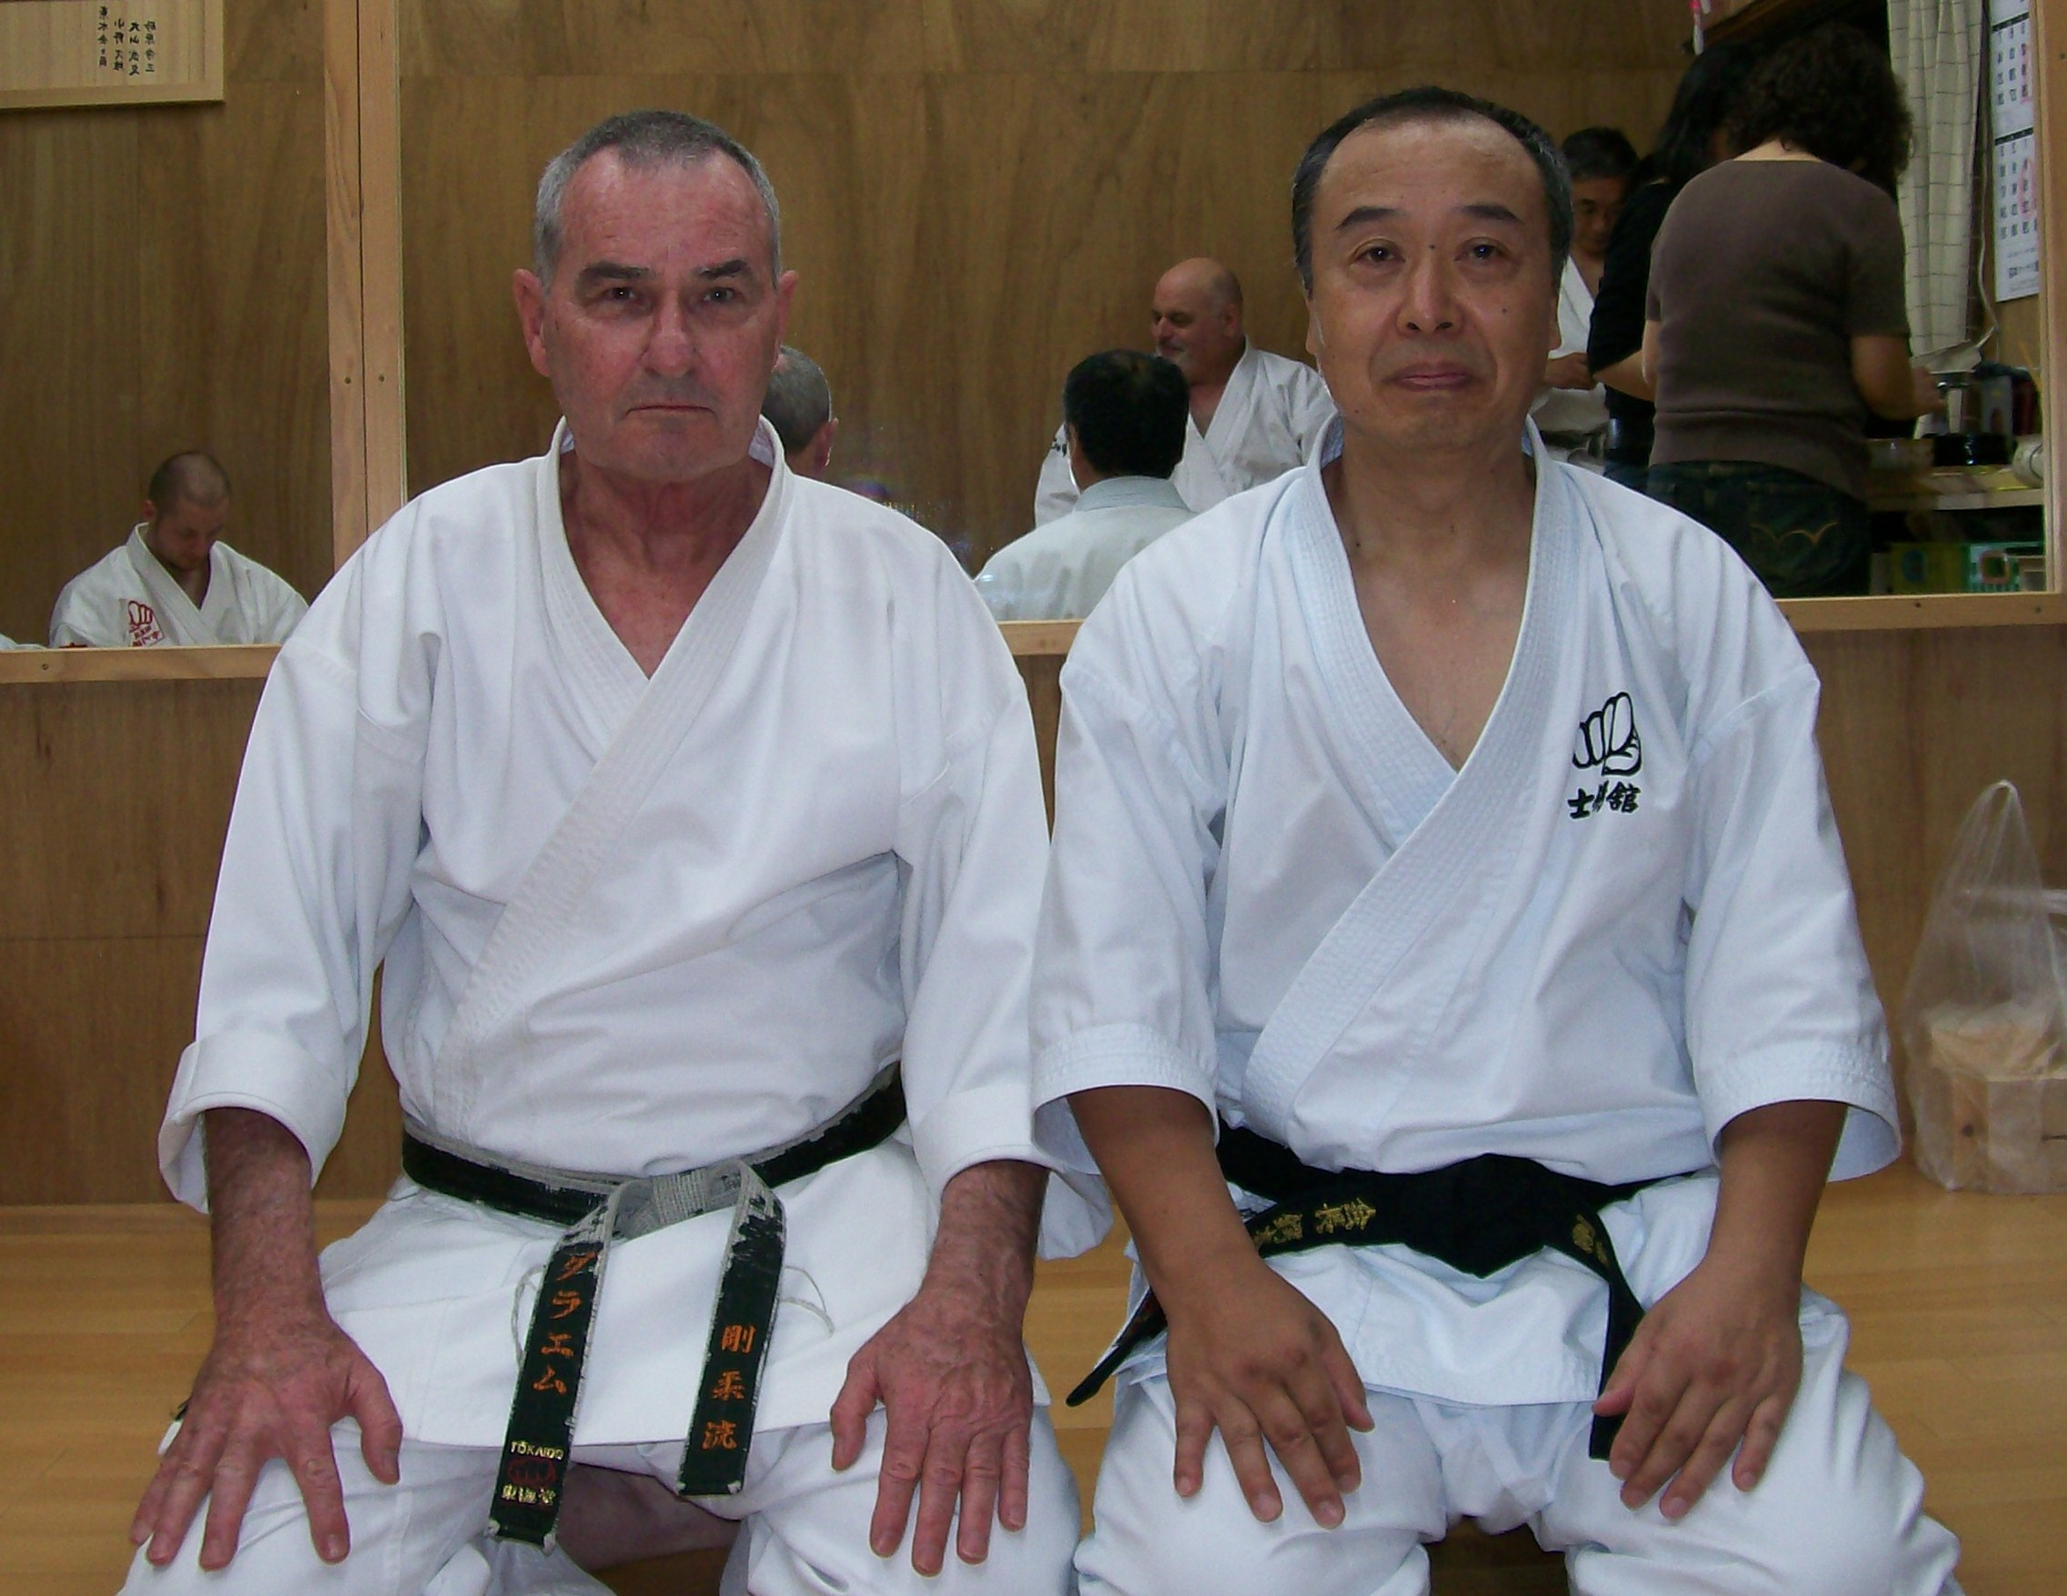
Sensei Tsubamoto with Shihan Graeme in the Shigaku Kan dojo.
Other highlights of the trip
There were many, many magic moments on the trip. Here are just a few….
* Visiting Ichikawa Sensei’s house and dojo.
* Sensei showed us a video of the last ever training session at Sensei Ichikawa’s dojo.
* Visiting Sensei Ichikawa’s grave to pay respects.
* Exploring Ueno Park!!!!
* Training in the same park in which Sensei Ichikawa trained. And training under his favourite tree!!!
* Drinking tea in Sensei Ichikawa’s favourite tea shop and talking to the owner who was one of O’Sensei’s friends.
* Breakfast every morning at “Pronto”……worth getting up for!
* Meeting many, many senior karate Masters in Sendai at the tournament.
*The trip with Chiba Sensei from Shiogama to Matsushima by launch, the visit to Zuiganji Temple and Godaido, a sensational lunch (what a view!!!!) at the Taikanso Hotel, and the visit to Aobajo Castle and Gokoku Shrine.
*Numerous visits to Asakusa to see the Sensoji Temple and buy all the tourist things like T-shirts, caps, gifts and so on.
* Meeting Kancho Taiani and his students. Making new friends is always good!! John Gorman (who started the global economic downturn as a Director of Morgan Stanley in New York……sorry John… we still think you’re the best), Sean Burden (the equivalent of our Suraj Fernando…..who was always the life of the party and had an uncanny ability to get his photo taken with girls) --Keith Davis, Shihan Khalid Newton, (Thank you for your friendship and advice…..and I still think you are Denzil Washington), Sarah Sizilich, Chris Lorentzen, Reggie Blanhard, Shuaib Newton (your Dad’s given you a hard act to follow!) and Andy Dominey from England who is a great professional photographer and IT expert with a wicked sense of humour.
Special Thanks
I really need to thank some special people………
# Kancho Robert Taiani
Thank you Kancho for your kind support and friendship over the years, and for making this trip possible. Your help, knowledge, counseling, support, advice, and friendship is gratefully acknowledged. We all owe you a great debt of gratitude.
# Sensei Tsubamoto and members of the Shigaku Kan. Thank you for accepting us with kindness and friendship into your group. Sensei, thank you for the meal after training, and Mrs Tsubamoto who always met us when we arrived at the dojo and made us feel welcome with drinks and a smile!! We will all work hard to justify your faith in us. Particularly I would like to mention Mr Ihara, Mr Hirano, Mr Ishii and Mr Kasajima. A special mention to Mr Iishii who helped me to reshape my knuckles on the makiwara!!! I understand you’re happy for me to train with you again!!!
# Yuki Tsubamoto , Officer in Charge of International Operations and Helping Me. Yuki, thank you for your continual support and advice, for the photos and technical answers. I greatly value your friendship. Yuki has just become a father again, with a boy named Kohaku, which means “White Tiger”. A brother for 2 year old Ryusei (means Dragon Star). Congratulations Yuki from all of the Shushinkai dojo in Australia. We hopefully will see Yuki in Australia next year.
# Sensei Hisao Ono. Sensei Ono showed us great kindness in Japan, took us around, had lunch with us, introduced me to many senior Masters and generally made us feel welcome and accepted. Sensei Ono, thank you for your emails and card. I appreciate your thoughtfulness and friendship and look forward to seeing you again soon. Keep up the good work in Kendo too!!!

THE YEAR AHEAD IN SHÚSHINKAI
I am looking forward with great anticipation to seeing you all when class recommences. I am sure 2010 will be exciting and productive for everybody!!! See you back in class………..

Shihan Graeme
Jan 2010

