JANUARY, 2009 No. 20
SHÚSHIN KAI GOJU RYU KARATE


kiai !!!!

2008 BREAKUP & GRADING RESULTS
A really successful Breakup night was held at the Hillside dojo on 18P^{thP} December. A good class was in attendance for a tough workout on basics, bunkai, sparring and kata for the grading. Many thanks to Bill who video’d the evening for us. Also re the raffle...many thanks to Amie who led the raffle.
Many, many thanks to those who supported the raffle by donating money and prizes.
And to all members who assisted the club by selling raffle tickets. Thank you all.
Alexander Ignatidis from Hillside won this year's Junior Student of the Year Award, and received a certificate and club shirt. Well done Alexander!!
Grading results, in no particular order ...Promoted to....
u9th Kyu
Phillip Meletis
James Cypreou
Joshua Chong
8th Kyu
Kimberley Johnston
Adam Blanche
U6th Kyu
Daniel Ganeshanantham
Amie Kelly
Alexander Ignatidis
U4th Kyu
Bridgette Gwynne
2nd Kyu
Gregory Goergiadis
Nicole Georgiadis

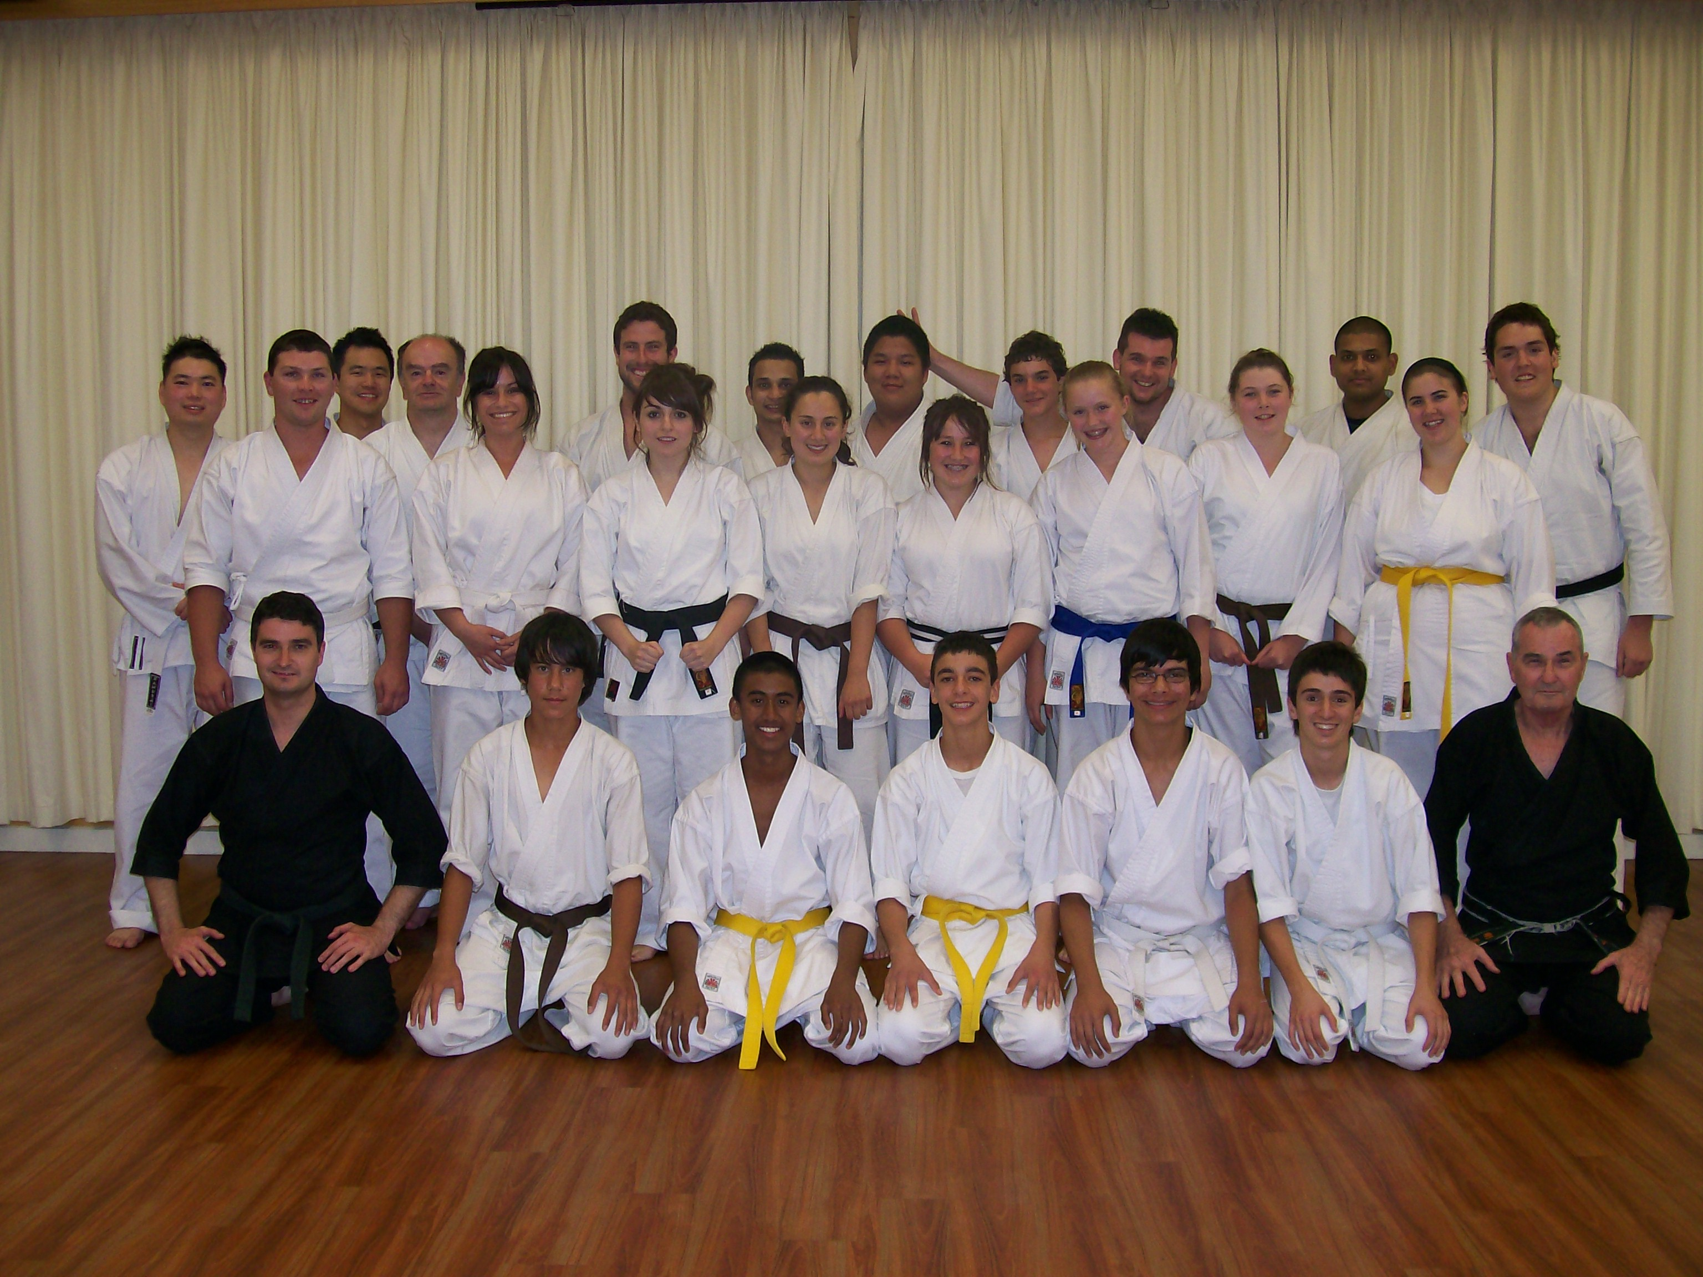
The class at the last night of training at Hillside, 2008.
2008 RAFFLE
The 2008 Raffle was drawn at the last night of training at Hillside. The winners were:
5th Prize: A collection of DVD’s
Valued at $40.00 Donated by Shihan Graeme.
5th Prize: went to Andrew Hammer
4th Prize: 1 bottle of Cabernet Sauvignon 2003 750ml & a tin of Royal Dansk Butter cookies 340g.

Valued at $ 60 Donated by Bridgette Gwynne and family.
4th Prize went to Vanessa Ulpiano
3rd Prize: Twin pack of Penfolds – Kalima Shiraz 2002 750ml and Thomas Hyland Chardonnay 2004 750ml
Valued at $80.00 Donated by Gayle Kelly.
3rd Prize went to Troy Aquilina
2nd Prize: The “Troy Aquilina” Food Hamper

Valued at $155.00 Donated by Troy Aquilina
2nd Prize went to Mark Cortis
1st Prize: “Pamper Yourself” Hamper
Teeth Whitening Treatment, $ 100 Gift Voucher from Cotton On, 2 Relaxation CD’s, Men and Women’s Beauty Pack, Facial consultation, 30 min clinical massage, hairstyle/ cut valued at $30. Total Valued at $500.00 Donated by Edwin, Bill, Tegan, Vanessa, Paul Sortino Essendon Natural Therapies - 29 Woodland Street Essendon 3040, Natspa - 29 Woodland Street Essendon 3040 and Zulema Salon - Shop 23-25, Strand Central Arcade 250 Elizabeth Street, Melbourne. Dominic 9663 4383)
1st Prize went to Lucas Kong's Father.

Many thanks to those who assisted the raffle by selling tickets, and a special mention to Amie who did a very professional job of organizing the raffle and prizes.
A few members sold none (thanks for your effort) and some never returned their tickets or money raised.
CAMPS & GRADINGS AT WU LIN
On the weekend of 28/29 June, our senior black belts attended a Tai Chi workshop at Wu Lin, conducted by Master Chen Yun Ching, the son of legendary Tai Chi Master Chen Pan Ling. This was the 5th Tai Chi/Kung Fu seminar conducted by Sifi Chen attended by Sensei Graeme. On this occasion the main item of study was the “Thunderstick” or “Walking Stick” form. The seminar also covered the “Form of China” Tai Chi form, Peng Chuan (Mountain Top Boxing) and Bagua.

The big event for us was the Black Belt Training Camp and Grading conducted by Kyoshi Sumarac on the weekend of 29/30 November, 2008. We had a really strong group in attendance, and everybody had an exhausting but happy time!! The highlight was the Grading in which Marc Del Cimmuto and Fabian Ulpiano were promoted to Shodan.
XMAS DINNER
On December 23rd^{P}, the club held its Annual Xmas Dinner at the Legends Bistro (named after Sensei Lincoln) at the Moonee Valley Racing Club. Some 32 people attended, and all had a great night!
SENSEI LINCOLN
This year we welcomed Sensei Lincoln back into regular training after his adventures as a police officer with Victoria Police. Sensei quickly re-established his reputation as a no-nonsense karate teacher.
WEBSITE
Our website TUwww.goju.com.auUT is still attracting a good number of visits since it was introduced in January 1999. At this time of writing, the site is has received 43,104 visits. 2.971 visits were for 2008. Many thanks to Suraj and Bill who look after the technical side of the site. The photo section has been recently updated, with photos from Wu Lin, the Training Day, Black belt Camp, and the Breakup Night at Hillside.
ASSOCIATED WEBSITES
If you are interested in finding out more about the Tai Chi, Mountain Top Boxing, Bagua and Hsing-I practiced and taught in our school, please visit TUwww.chenpanling.comUT Additionally, please visit Kyoshi’s website TUwww.jamessumarac.comUT which includes photos from the various camps and seminars.
NEW STRATEGIES
In December 2007, a group of senior members met at Sensei’s house to discuss strategies and plans for guiding the club into the years ahead, to help attract new members, and how to retain members. As a result of this meeting we now have a PowerPoint Presentation which we send to people enquiring about joining our club. The short presentation introduces our club, answers the usual questions and details training times/venues and costs. It has been very well received by people seeking information and has led to a number of new members. We also produced a short DVD which includes interviews with a number of our members and footage of classes in action at Hillside. The DVD is for walk-in visitors, giving them something to take away. Many thanks to Bill for the filming, Vanessa for the editing and all the members who contributed to its content.
ANNUAL TRAINING DAY
On Saturday, 4th October we held our fourth Annual Training Day and Competition at Ginifer dojo. Thank you all for attending and helping to make the day enjoyable and productive!! Everybody had a great time learning Naifanchi Bunkai, bridge and roll, and Hsing-I.
Our Black Belt Grading was great too, with Marc Del Cimmuto and Fabian Ulpiano achieving their Black Belts in our dojo grading. They went on to attend the Black Belt camp in November and demonstrated their skills to Kyoshi, after which they received their new belts and certificates.
Our Shushin Kai Kumite Championships were conducted with great spirit and skills. Bridgette Gwynne from the Hillside dojo was the winner and was presented with a plate engraved with her victory! Well done Bridgette!!! The tournament was designed to incorporate a “grading” or “handicap” system so lower grades and females received higher scores for fighting higher grades, thus giving everybody a fair chance of winning. Also, the sparring was not along competition lines as experienced at AKF events, but was based on close quarter sparring of 30 seconds duration.
I would also like to thank Asanka and Troy for arranging lunch/drinks etc. Also Marc's mother Anna who baked cakes for us and Kimberley from Westmeadows dojo who brought biscuits!!
Bill and Edwin for administering the kumite, and Sensei Lincoln who not only refereed for 2 hours and taught several sessions, but who planned and organised the whole event. Thanks to you all!
THE LITTLE PUNK IS BACK!!!!
That little punk, Suraj Fernando (Nidan) returned to class late in 2008 after wearing out his welcome in England where he has been working for the past year. Suraj is fitting in some training in between partying and will be with us for a few more months before returning to England. Welcome back Suraj!!!
PROGRESS IN 2008
During 2008 we consolidated our journey into the syllabus of Gojukensha under the guidance of Kyoshi James Sumarac (7P^{thP} Dan), Chief Instructor of Kakurinkan Goju Ryu Karate, with which we are affiliated.
During the year we also saw the usual comings and goings with some people trying karate for a short time before disappearing.
Unfortunately we lost a couple of new Shodans who only continued their training for a few short weeks before leaving the club. It’s disappointing that people put in such a great effort to achieve their Black Belts and then stop training. There are two reasons why this is a disappointment…. Firstly, karate training STARTS in earnest when you achieve your black belt. Gaining shodan means you have put in the preparatory work needed before being exposed to the real meaning of karatedo through higher level training. Secondly, it means that the new shodan has not “put back in” to the development of the club or others through assuming higher responsibilities within the club such as teaching, coaching and helping others. This is also a very important lesson on martial arts.
We wish to thank our new members for choosing our club, and hope that you enjoy your karate journey.
We would like to welcome Joshua Chong, Kimberley Johnston, Adam Blanch, James Cypreou, and Phillip Meletis who joined us during 2008, and who have stayed.
We had some major events during the year…..the very successful Annual Training Day, and a Black Belt camp. We had Tai Chi seminars as well as three successful Kyu gradings.
The most important event of all was the Black belt camp during which a grading was held, and we gained 2 new Shodans.
The club now has 13 Black Belts:- seven 1st Dans, two 2nd dans, two 3rd dans, one 4th dan and one 5th dan.
IMPORTANT NEWS : FEES
This year there will be NO increase in the clubs fees.
Fees are:-
Annual Membership Fee $75
UMonthly Training Fees
Senior (12 yrs & over & Juniors 2 hrs per night) $65
Casual fee for this group $15 per session
Juniors (11 yrs & under, 1 hr per night) $50
Casual fees for this group $10 per session.
Special discounts
If members pay fees 3 or more months in advance we will apply a 10% Discount. This means the senior fee is $175.50, for 3 months, which is $4.50 cheaper than the current rate. The Junior rate is $135.
Would all members please pay their fees promptly on the FIRST training night of each month. (Which means of course, bring your fees to the first night back in class).
POLO SHIRTS
Any club members wishing to obtain the club’s white polo shirt embroidered with the club’s name should see me to arrange obtaining one. This shirt is worn by club members when attending official club events, tournaments and so on. Price:- $35.
BLACK TRAINING TOPS
Embroidered with the Shúshin Kai name front and back, made from non-pilling polar fleece. Please see me to arrange your top if you would like one. Price is $55, adult sizes only. These tops are designed to be worn over your uniform and are great for wearing on those cold nights. They are the only additional clothing permitted to be worn in class.
2009 CLASSES START DATES
Westmeadows Dojo (Raleigh St Westmeadows): Monday, 2nd February at 7.15 pm
Ginifer dojo (Carrick Drive, Gladstone Park) Wednesday, 4th February. At 7.00 pm
Hillside Dojo (Banchory Ave, Hillside): Tuesday3rd February
BETWEEN NOW & THE START OF CLASSES
I have spoken to several members since classes finished last year, and received emails from others. I am particularly pleased that these people are continuing to do some training and fitness work (such as running) over the Xmas/New Year period. There is no doubt this is a dangerous time for your fitness and standard, not to mention weight gain!!
Please make sure you do some training before class comes back, so we can hit the ground running!!
WINDS OF TRADITION
Kyoshi’s textbooks “Winds of Tradition” form the basis of our Syllabus up to and including 1P^{stP} Kyu. We have arranged for these books to be available to members for a special discount price. Please see me to arrange your copies.
THE YEAR AHEAD
I am looking forward with great anticipation to seeing you all when class recommences. I am sure 2009 will be exciting and productive for everybody!!! See you back in class………..
Shihan Graeme

